COLLEGE OF COMPUTER STUDIES AND MULTIMEDIA ARTS

IT0049
(WEB SYSTEM TECHNOLOGIES)

TECHNICAL FORMATIVE ASSESSMENT
2

FROM ARRAYS TO A REAL DATABASE

Student Name / Group Name: | Lukexander Virgilius P. De Guzman
Members (if Group):
  Name | Role
Section: | TC-32
Professor: | Sir Calleja
PROGRAM OUTCOME/S (PO) ADDRESSED BY THE LABORATORY EXERCISE
- Design, implement and evaluate computer-based systems or applications to meet desired needs and requirements. [PO: C]

COURSE LEARNING OUTCOME/S (CLO) ADDRESSED BY THE LABORATORY EXERCISE
- Apply advanced web development principles in creating, debugging, validating, and securing database-backed web applications. [CLO: 2]

INTENDED LEARNING OUTCOME/S (ILO) OF THE LABORATORY EXERCISE
At the end of this exercise, students must be able to:
- Configure CodeIgniter's database connection settings.
- Create a MySQL database and tables using a provided schema.
- Build CodeIgniter Models for the Customer Accounts and User Accounts pages.
- Retrieve records with Query Builder and display them in a view.

BACKGROUND INFORMATION
The POS application from the previous activity stored its data in static PHP arrays, which reset every time the server restarts. This activity replaces that temporary storage with a real MySQL database. CodeIgniter's Model class wraps a database table and gives you Query Builder methods — such as findAll() — for retrieving records without writing raw SQL.
A good rule for this activity: once a page's data comes from a Model, its controller and view code should look almost identical to the static-array version. Only where the data comes from changes.

GRADING SYSTEM / RUBRIC
CRITERIA | Description
Functionality & Requirements Completeness (40 points max) | All required pages and features are present and work as specified in the activity instructions.
Code Structure & Organization (25 points max) | Controllers, models, and views are separated correctly and follow the framework's conventions; code is readable and sensibly named.
Database Design & Query Usage (20 points max) | The database and tables match the provided schema, records are retrieved through a Model using Query Builder (not raw SQL), and the results display correctly in the view.
Documentation & Submission Quality (15 points max) | The GitHub repository is organized and complete, the README explains how to set up and run the project, and the hosted link is live and matches the submitted code.

LABORATORY ACTIVITY
You will extend the POS application from TFA1 by replacing its static arrays with a real MySQL database. Use the schema below.
- Configure your CodeIgniter .env database settings to connect to a local MySQL database.

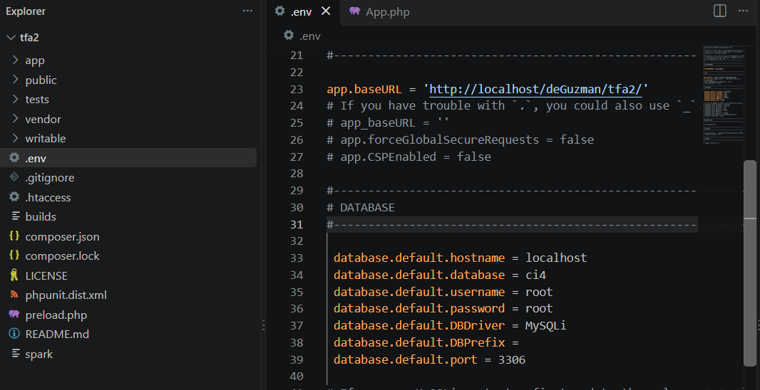

- Create the database and the customers and users tables using the schema below:
CREATE TABLE customers (
id INT AUTO_INCREMENT PRIMARY KEY,
full_name VARCHAR(100) NOT NULL,
email VARCHAR(100) NOT NULL,
phone VARCHAR(20),
created_at DATETIME NOT NULL
);

CREATE TABLE users (
id INT AUTO_INCREMENT PRIMARY KEY,
username VARCHAR(50) NOT NULL UNIQUE,
full_name VARCHAR(100) NOT NULL,
created_at DATETIME NOT NULL
);

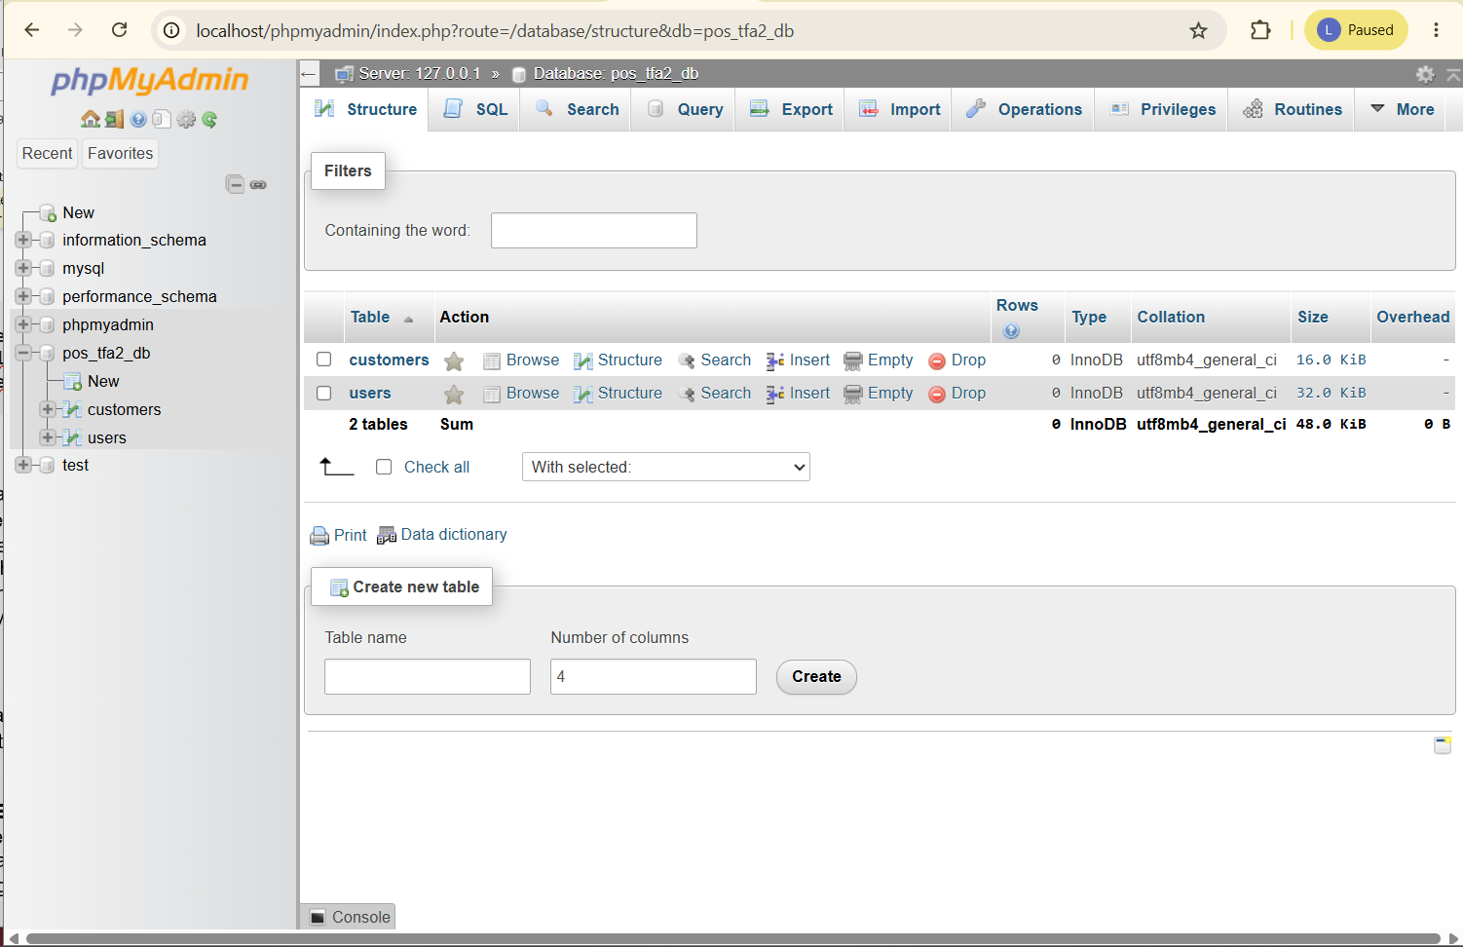

- Populate each table with at least 5 sample records.
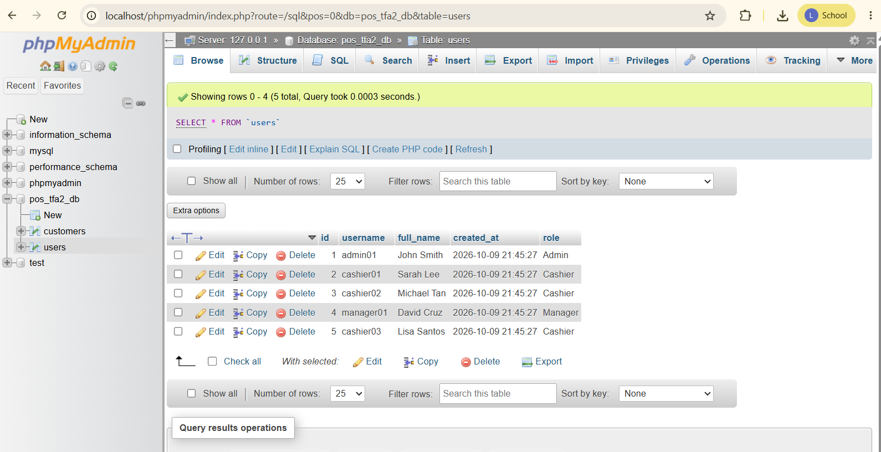
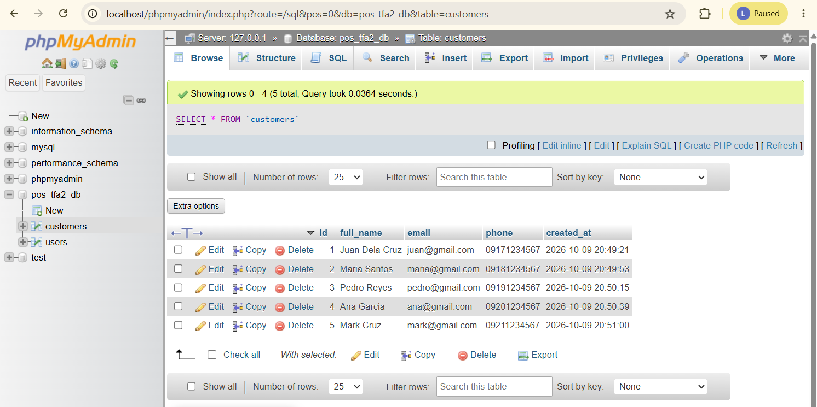

- Create a CustomerModel and a UserModel.
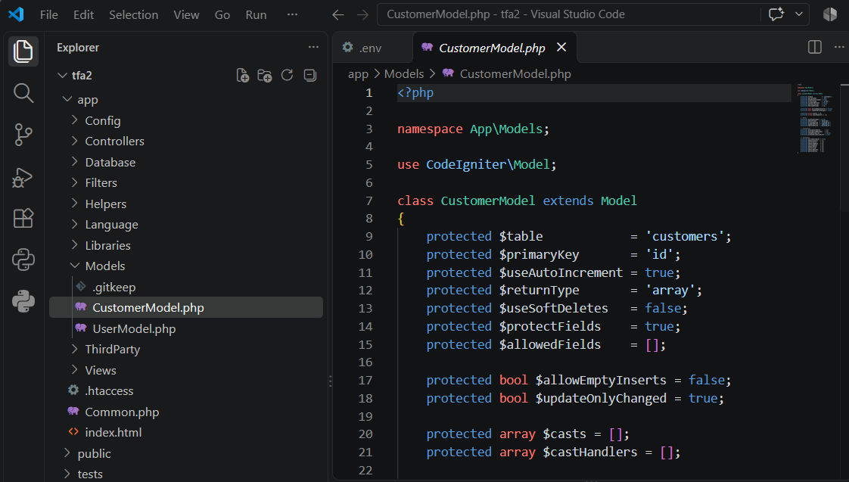
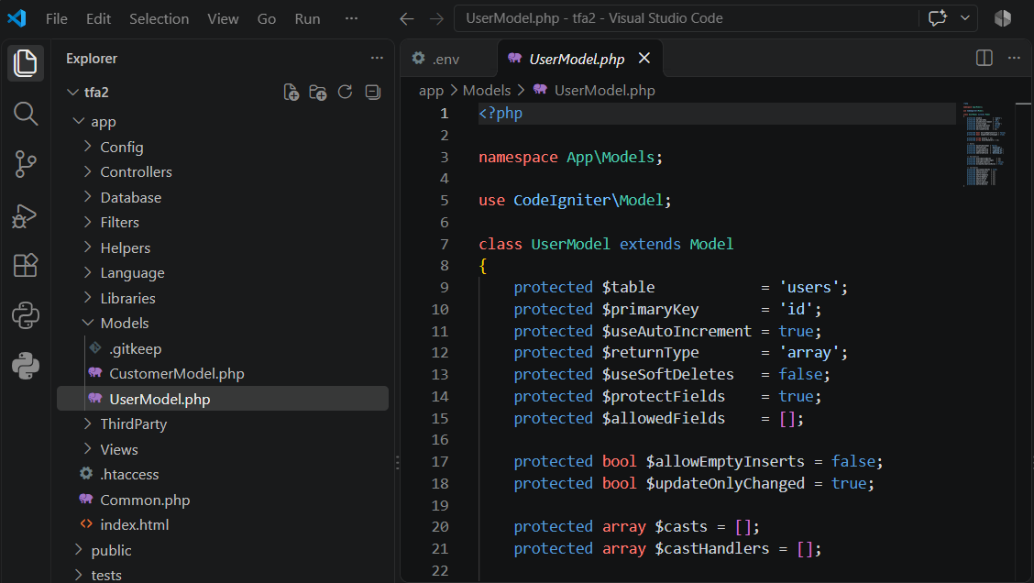

- Update your Customer Accounts and User Accounts controllers to retrieve records through their Models instead of static arrays.

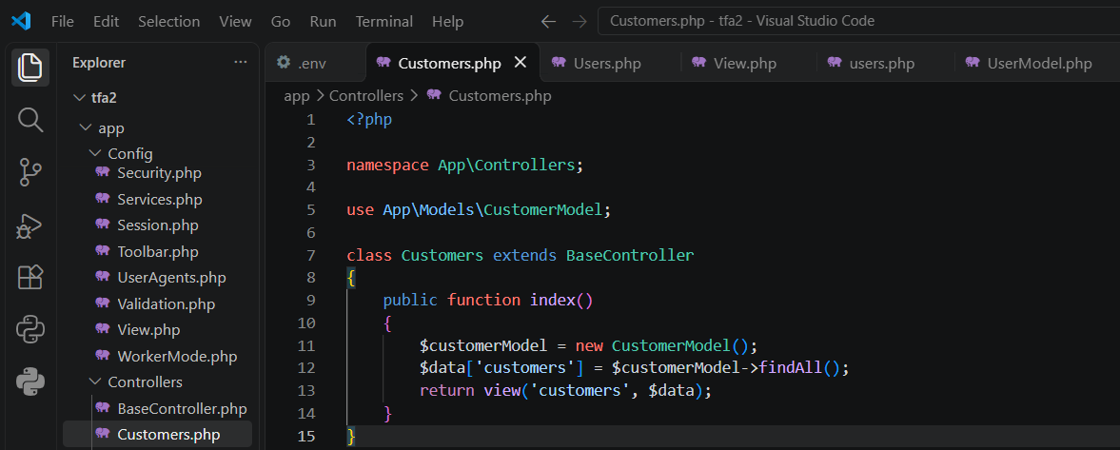
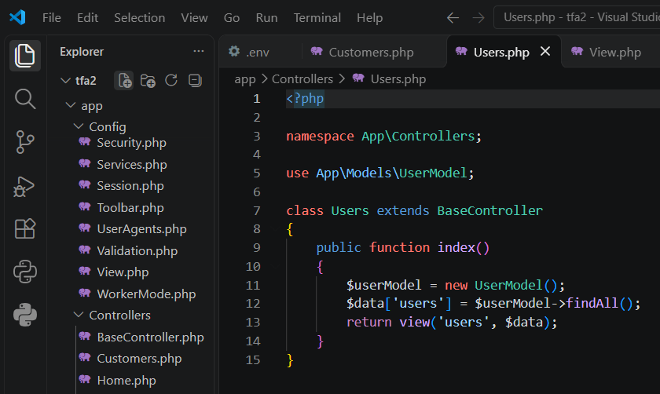
- Confirm the views display the retrieved database records the same way they displayed the static array data in TFA1.
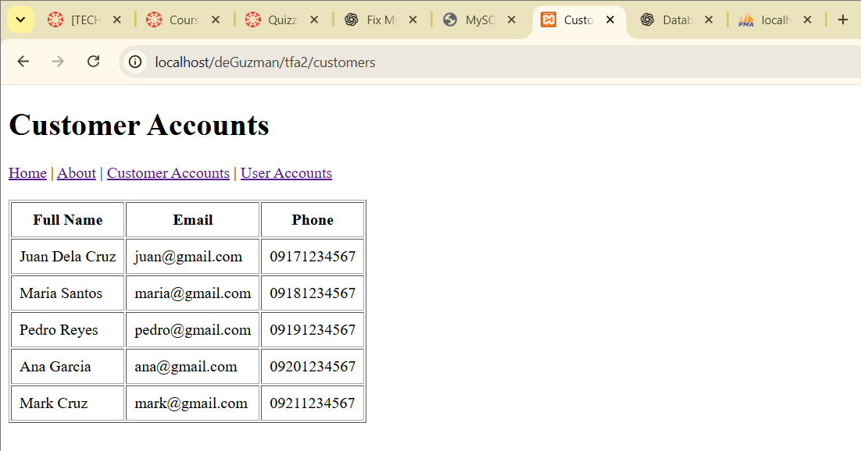
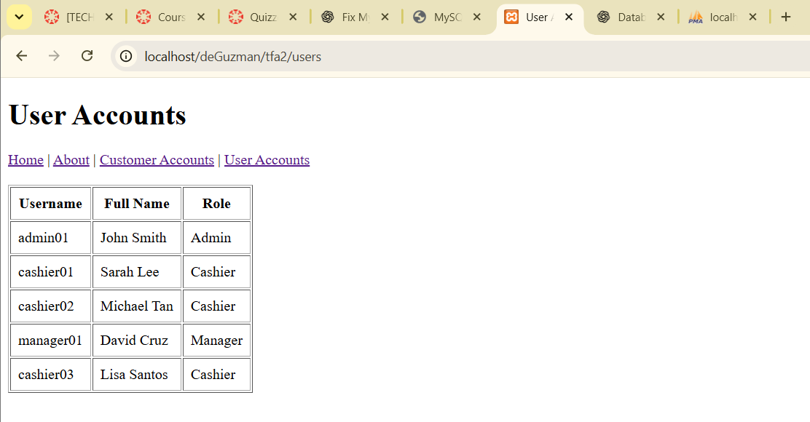
Submission Requirements:
- A link to a GitHub repository containing your raw project files, including your database export.
- A link to your hosted, working version of the application.

Chatgpt Screenshots:
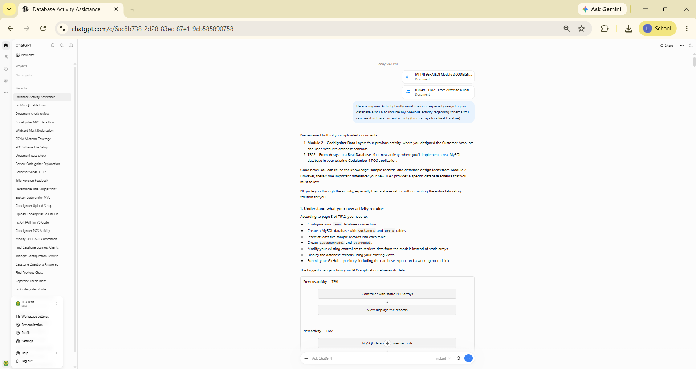
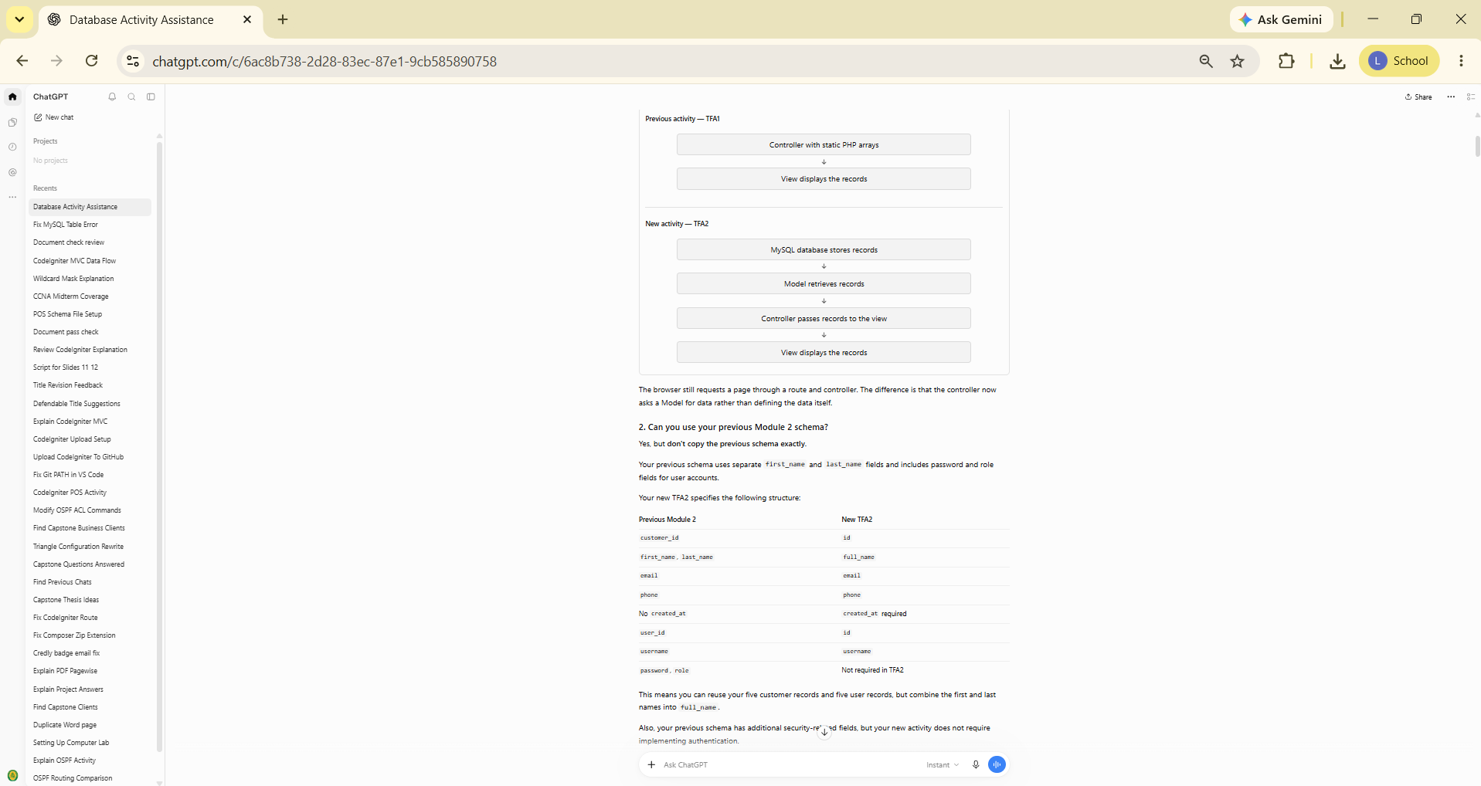
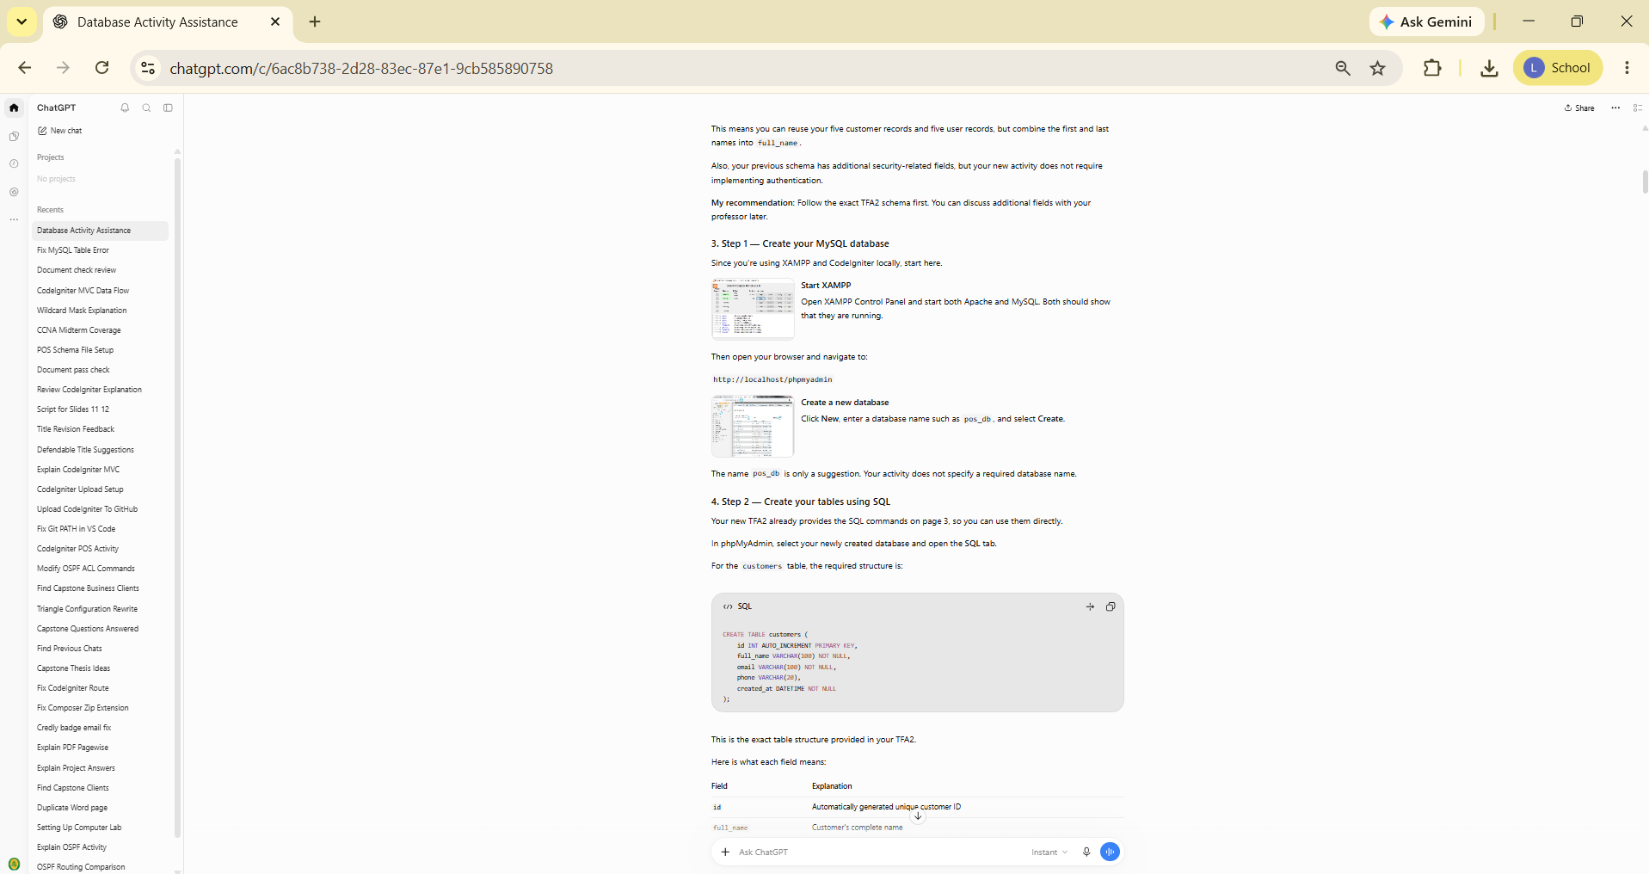
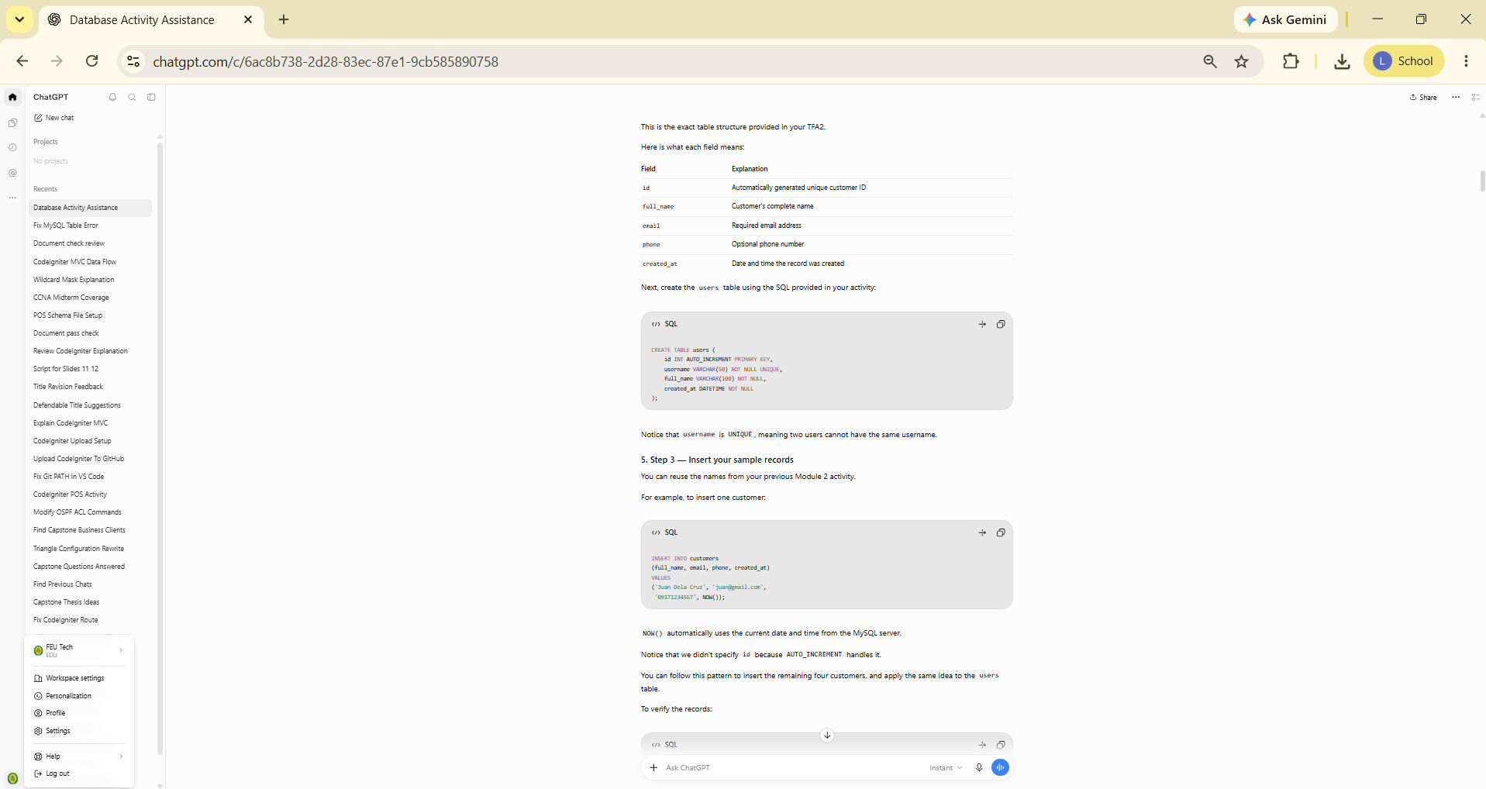
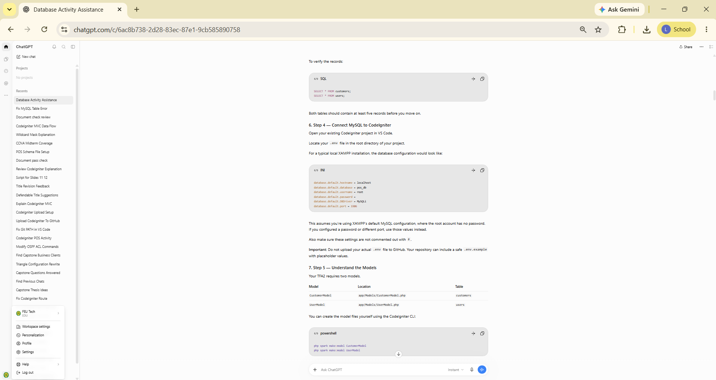
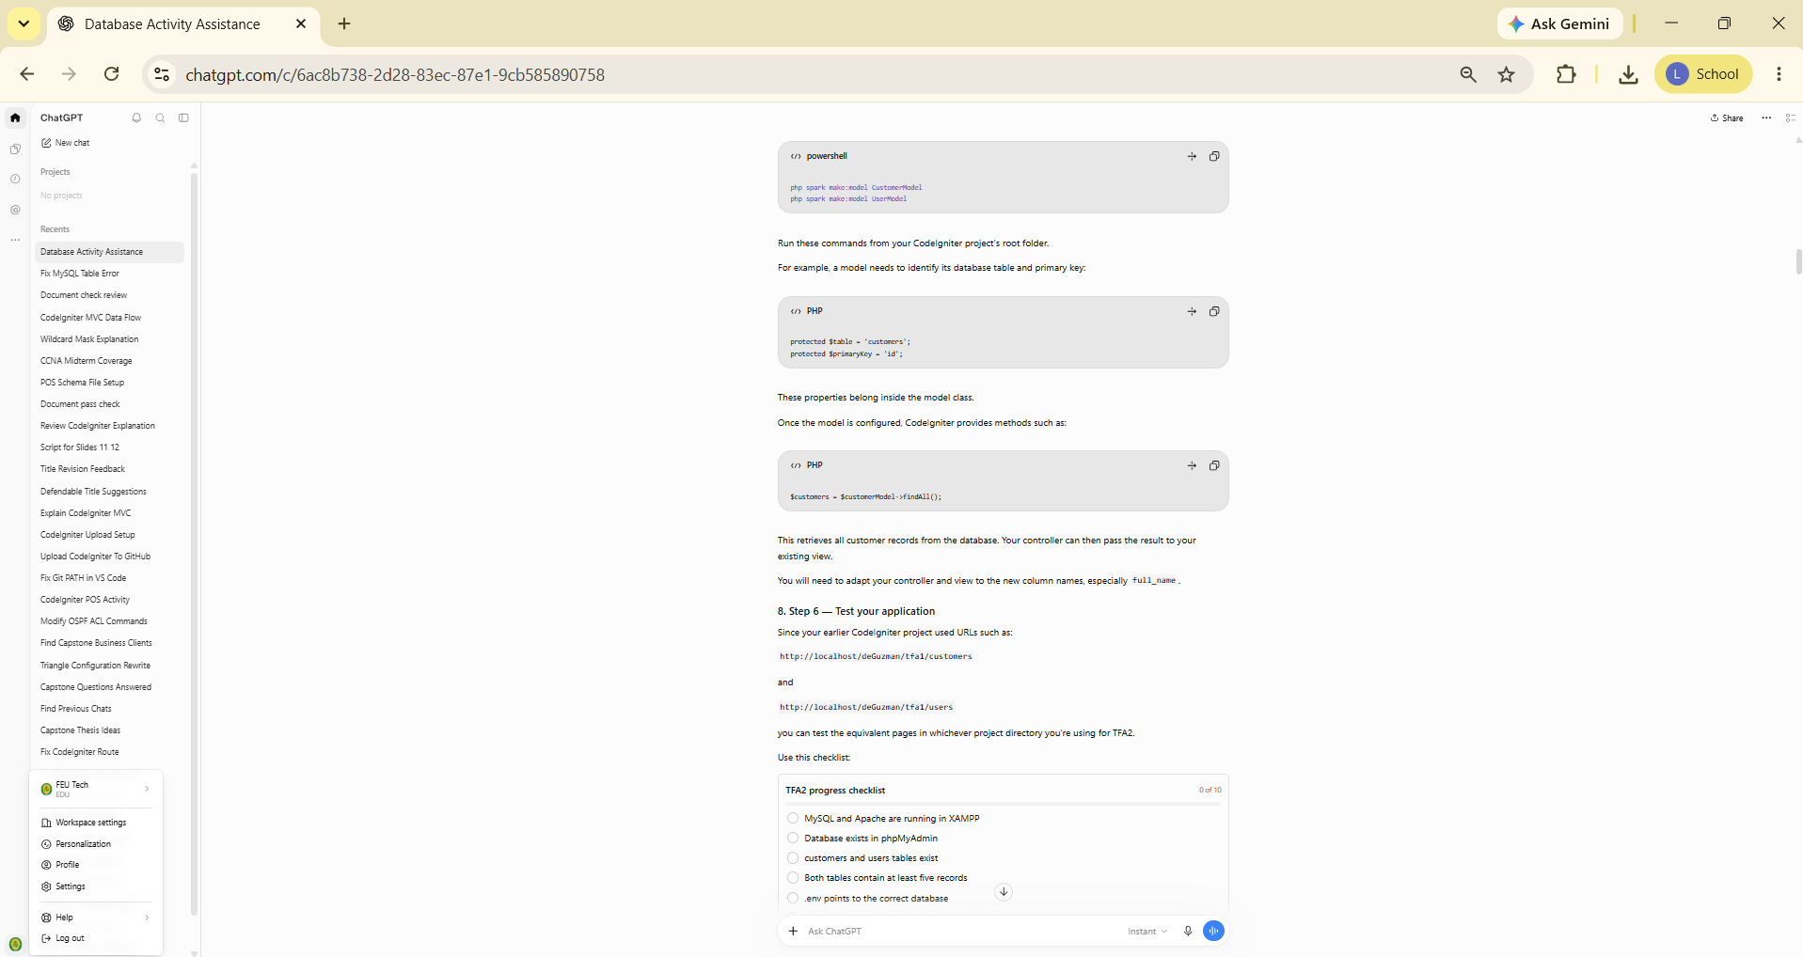
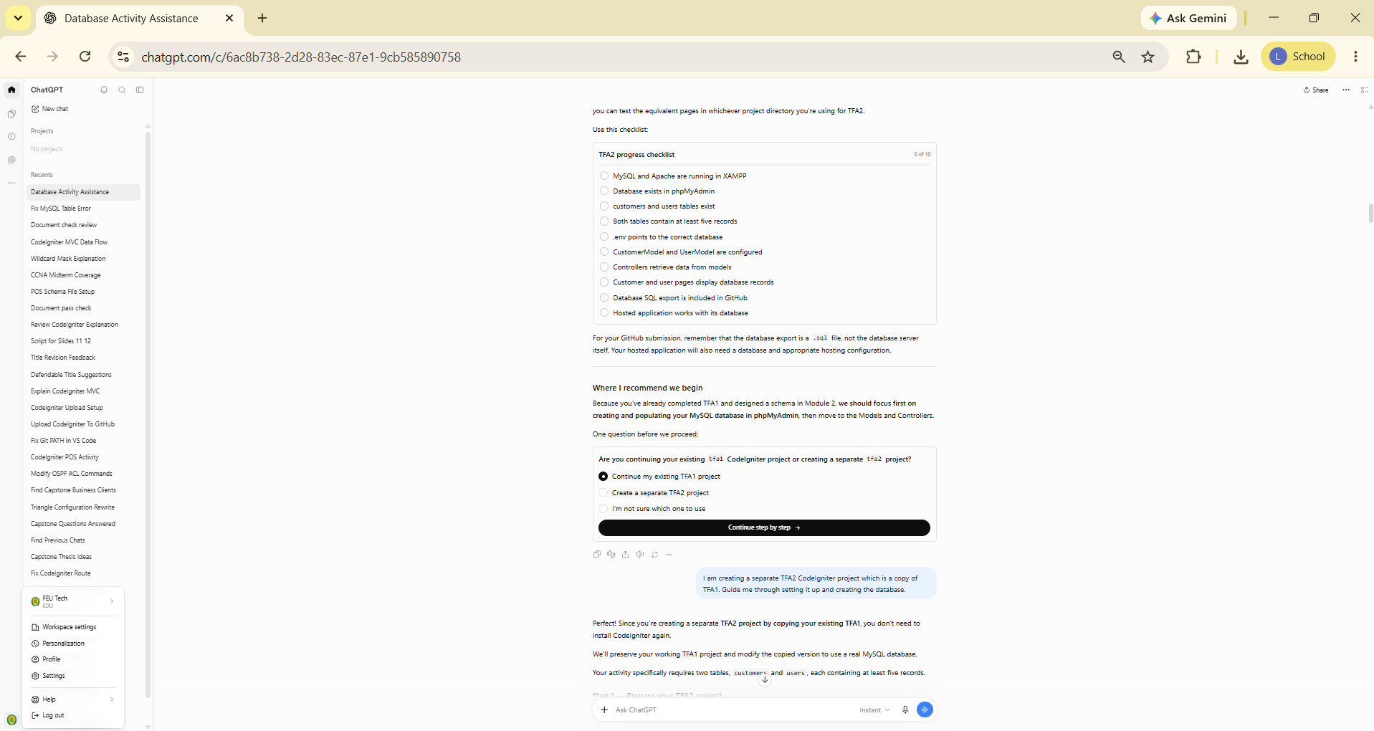
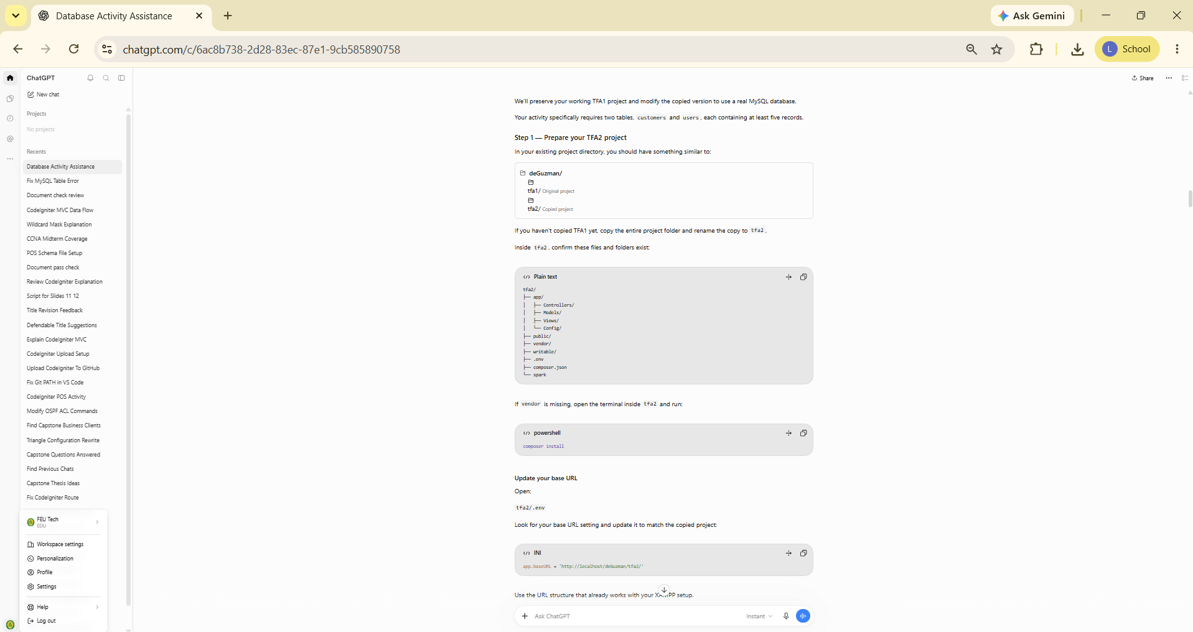
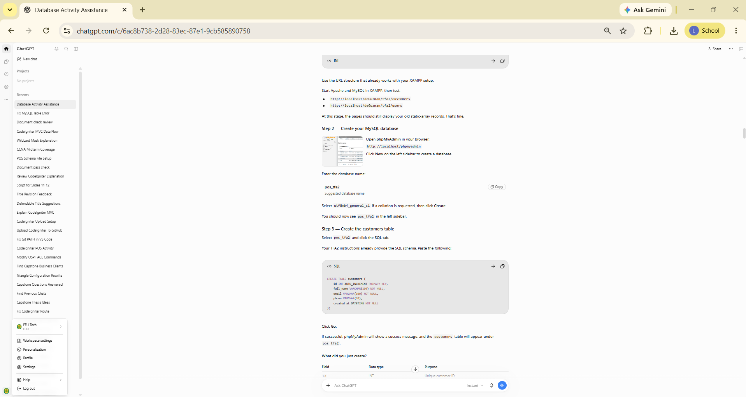
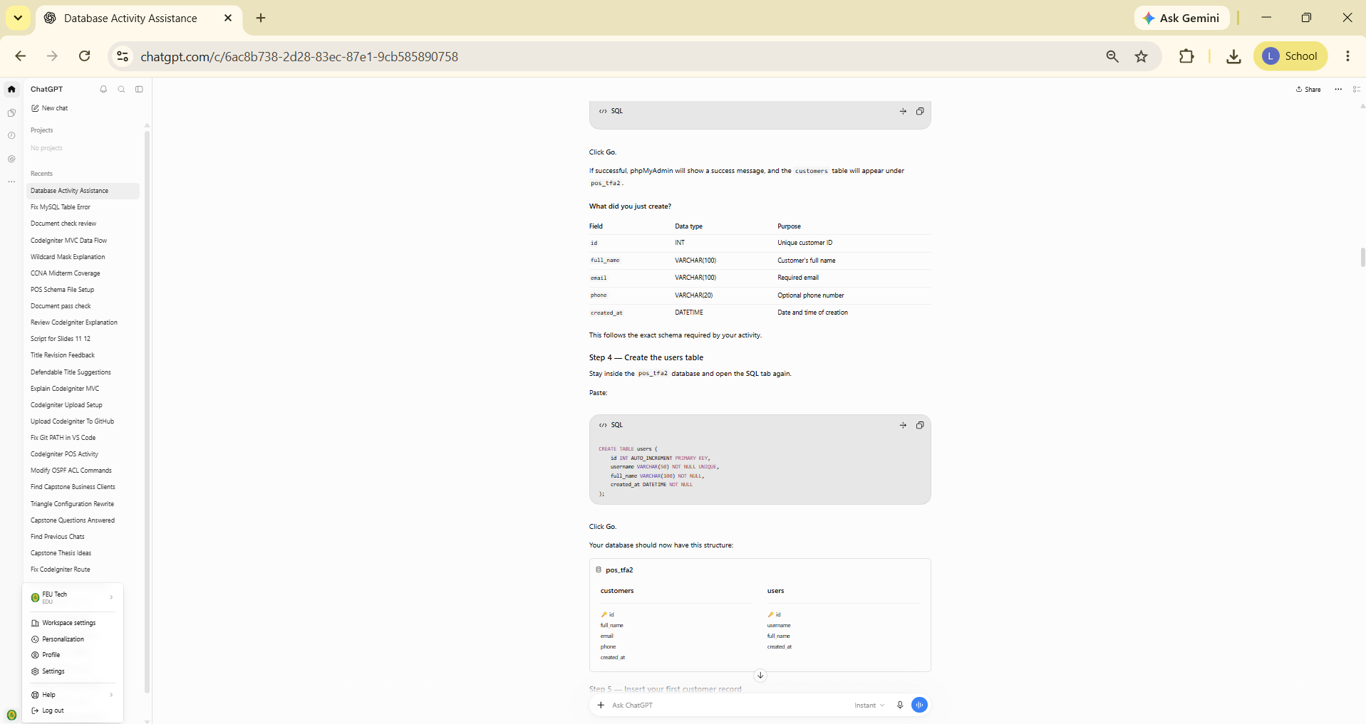
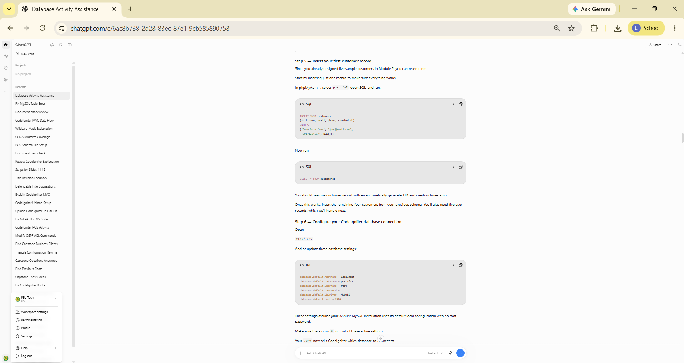
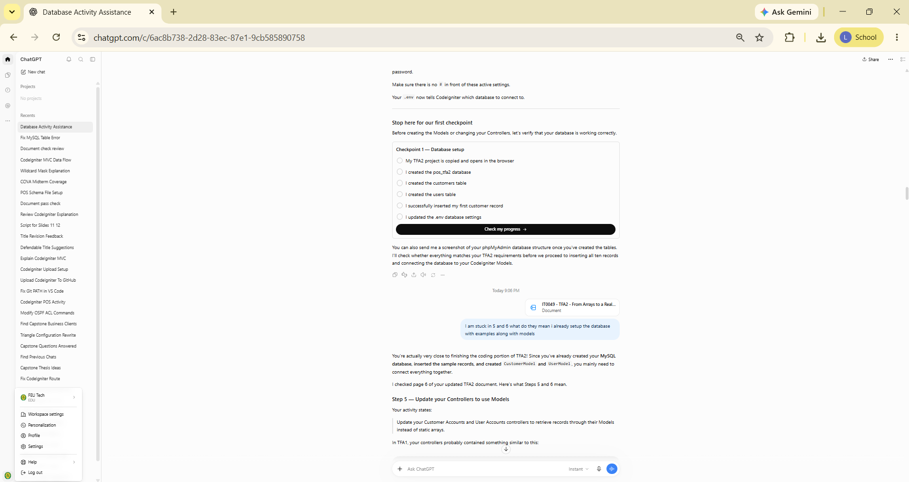
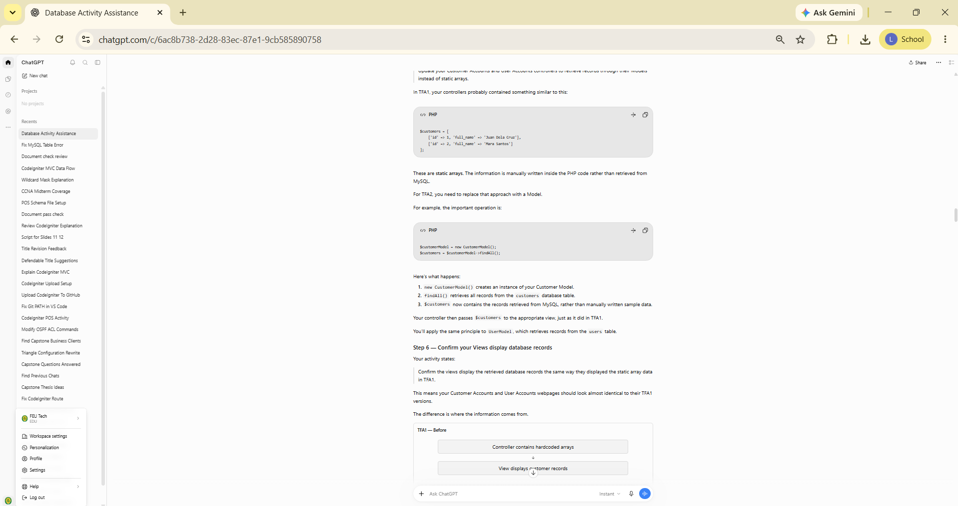
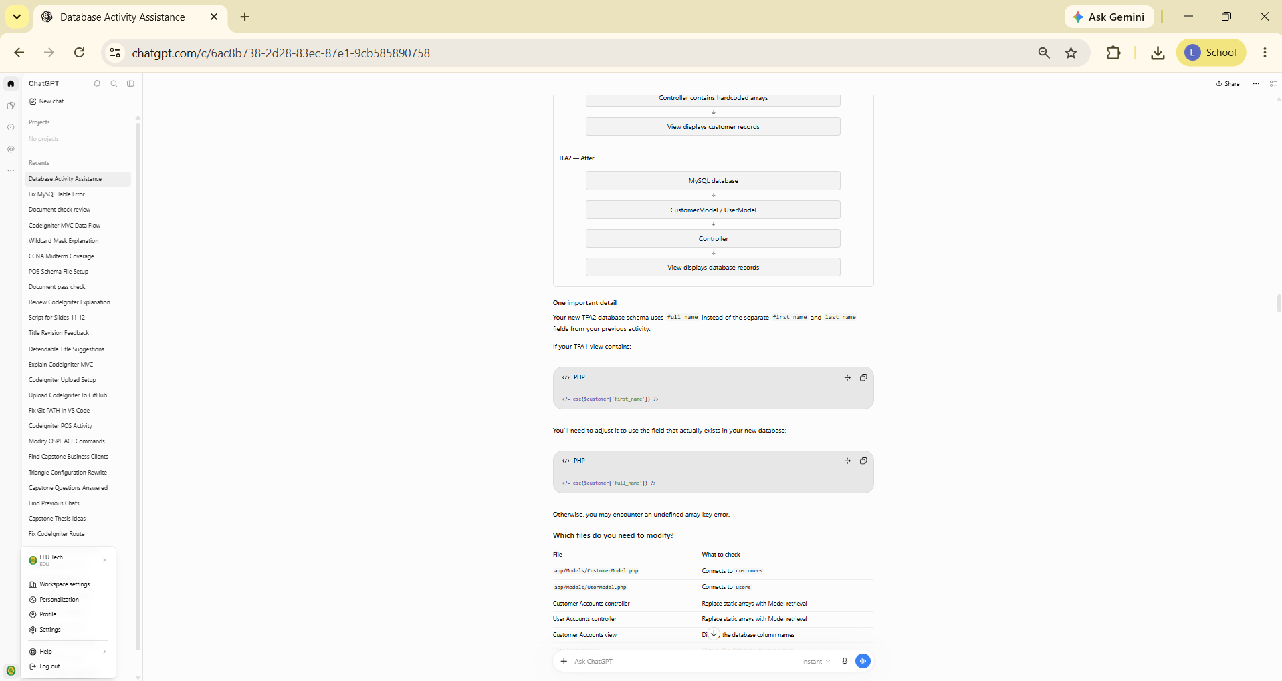
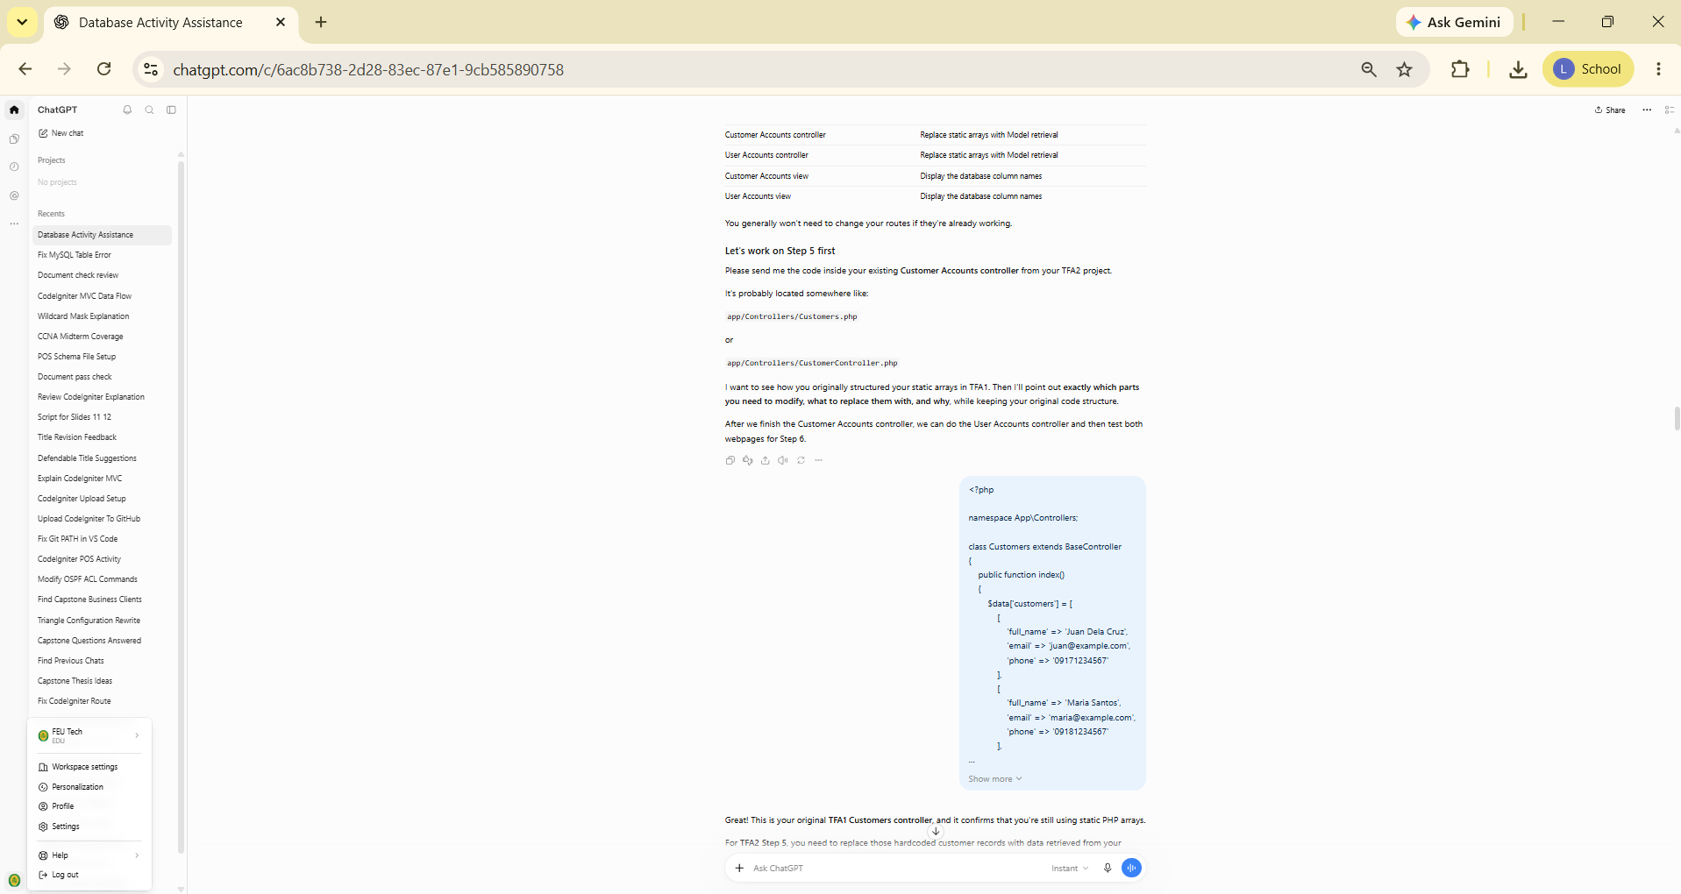
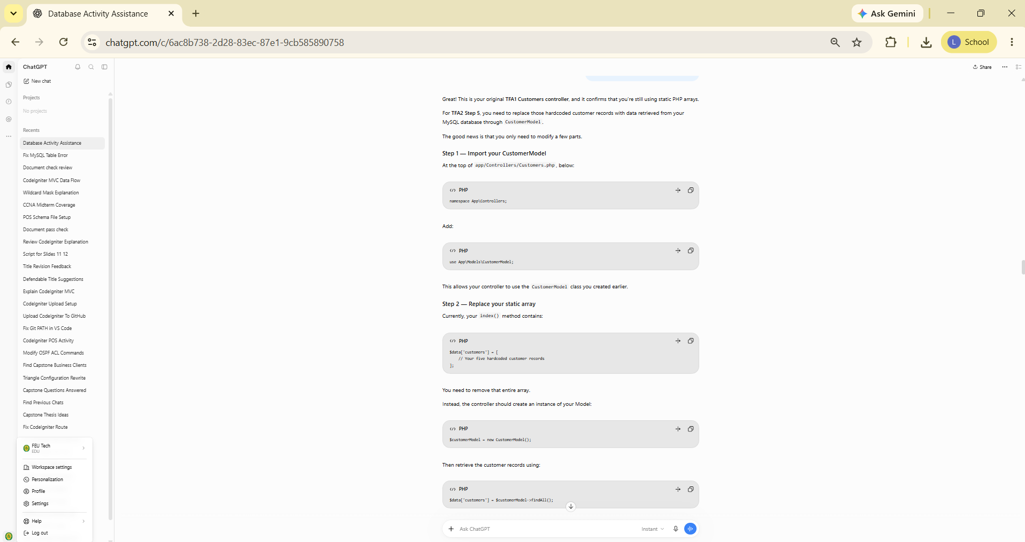
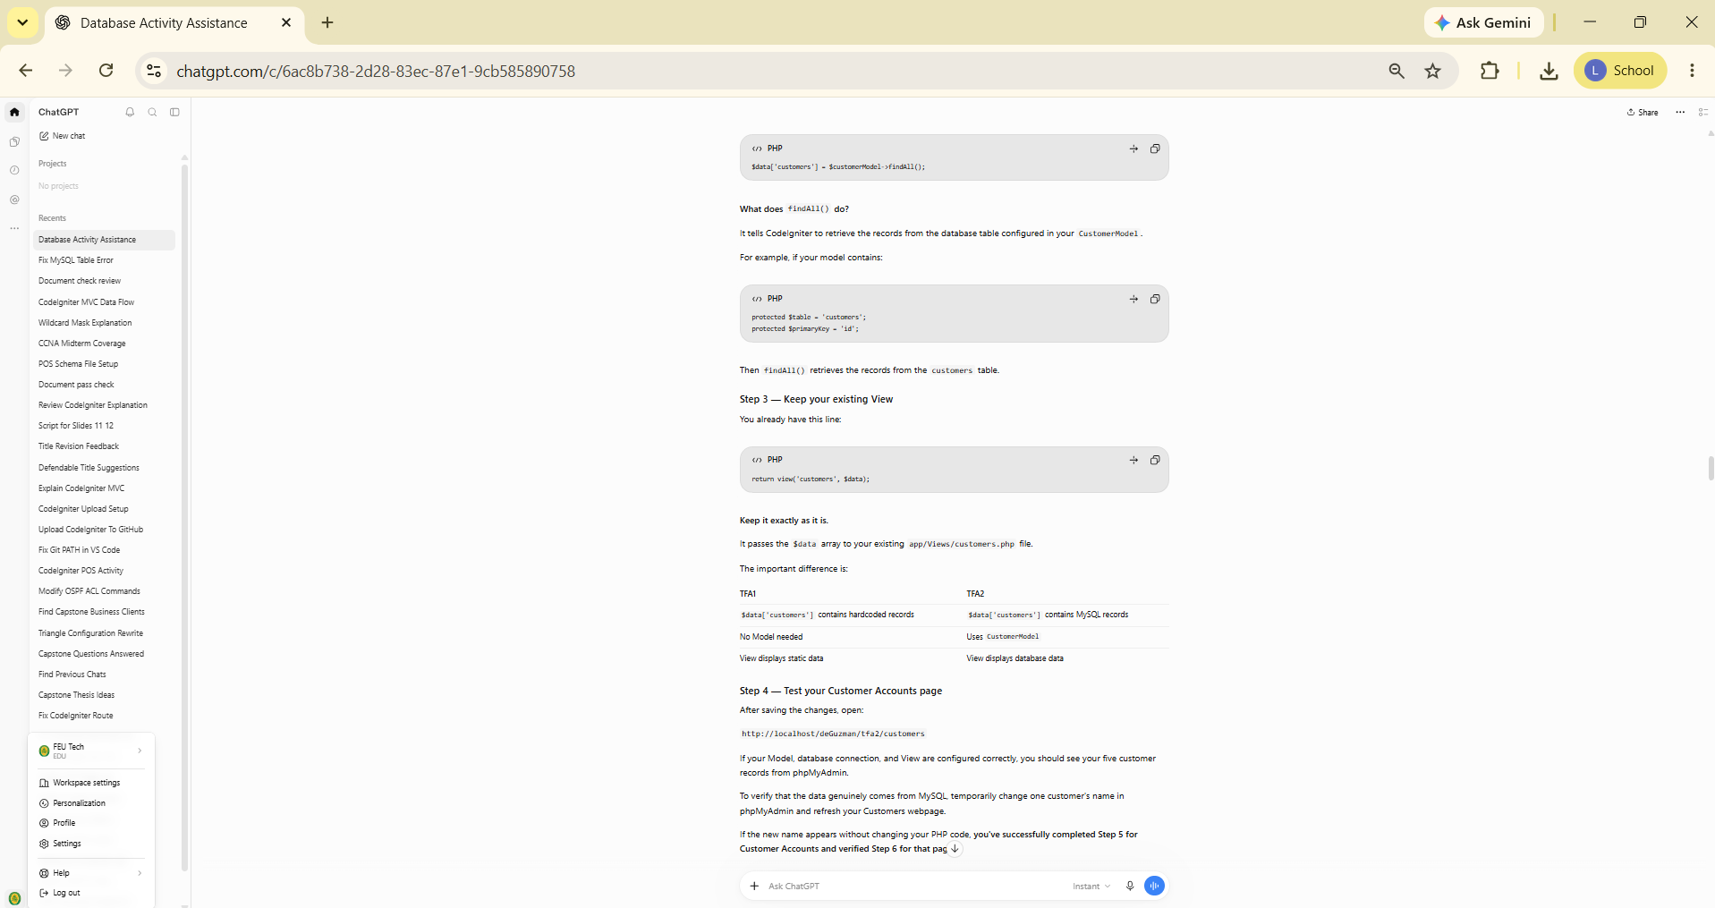
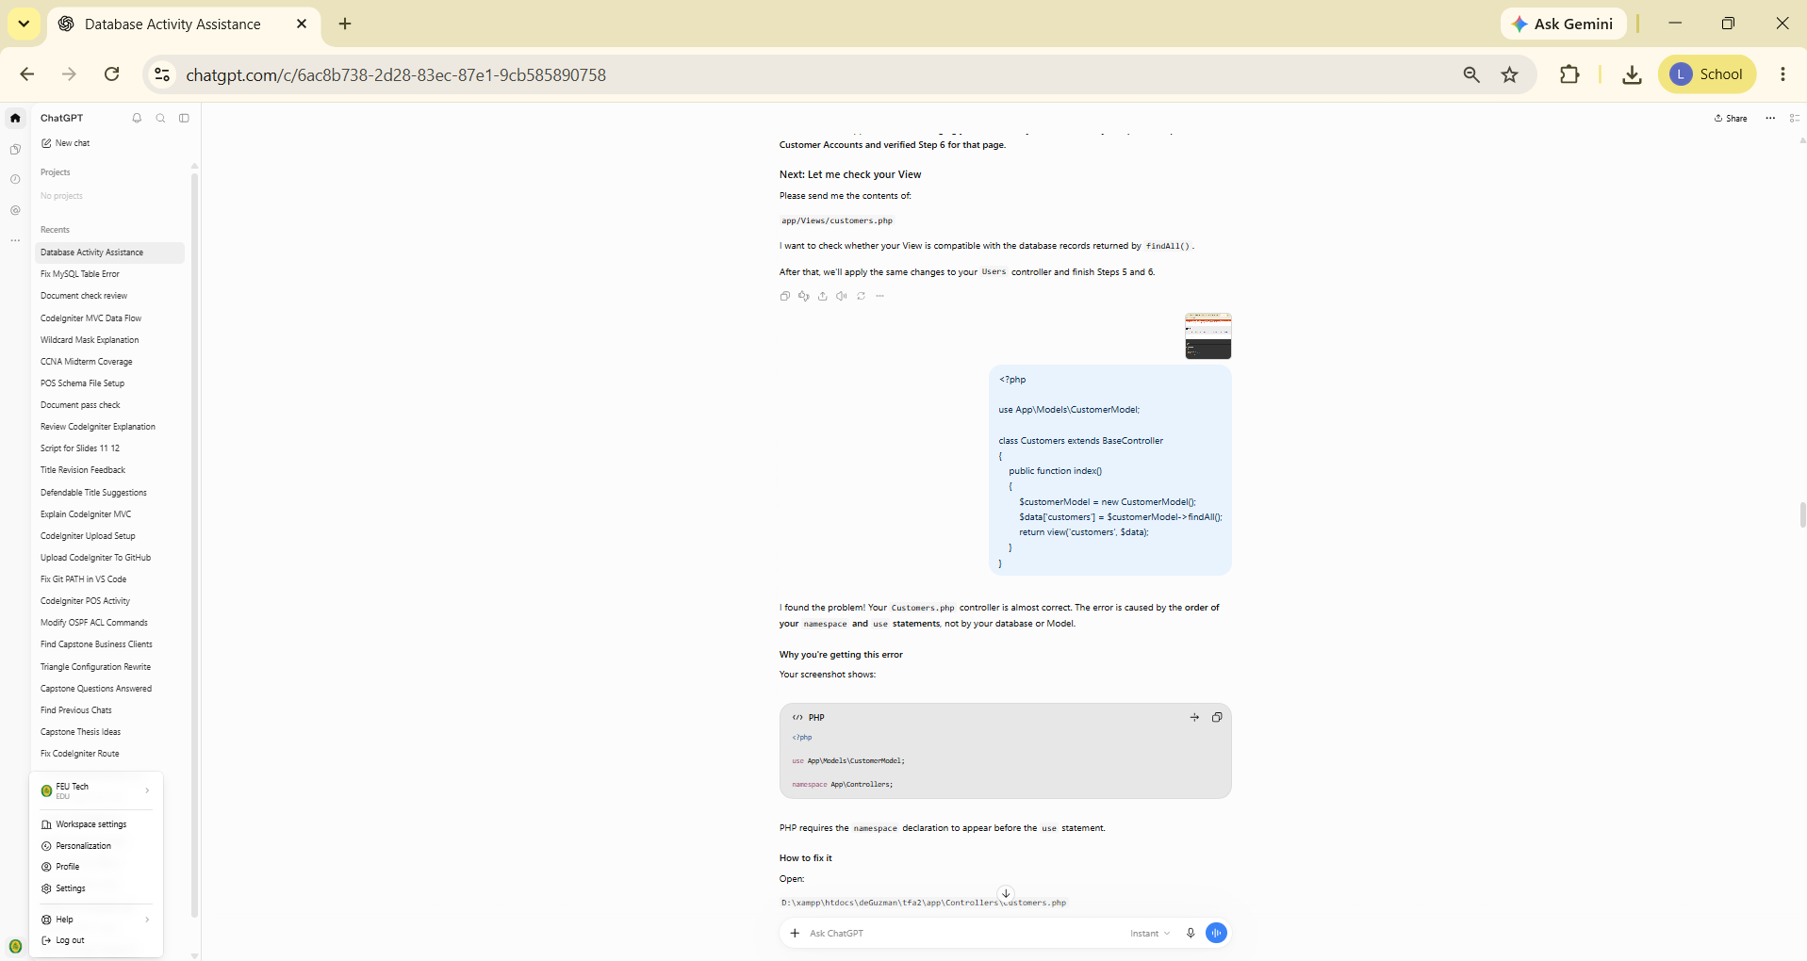
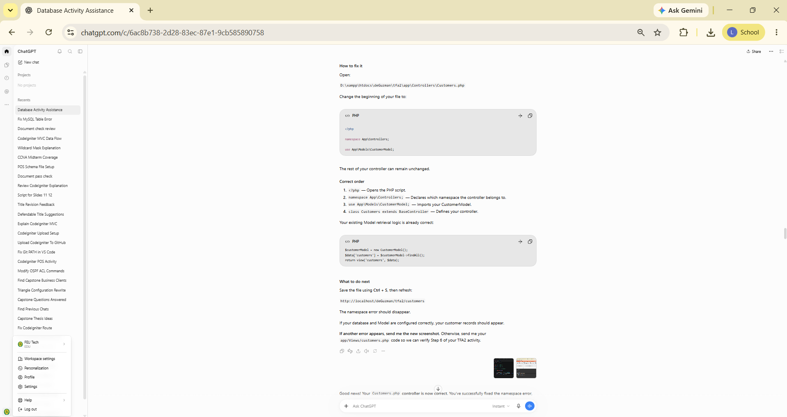
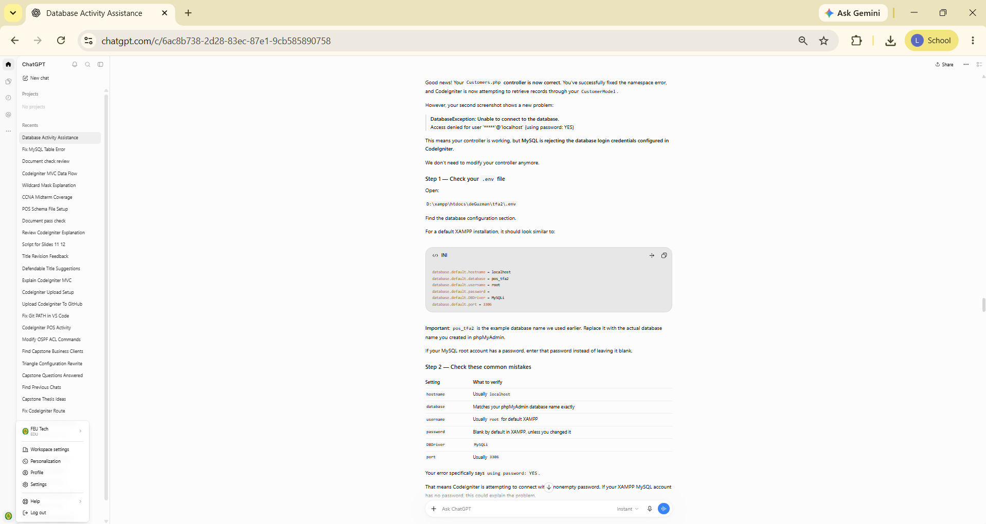
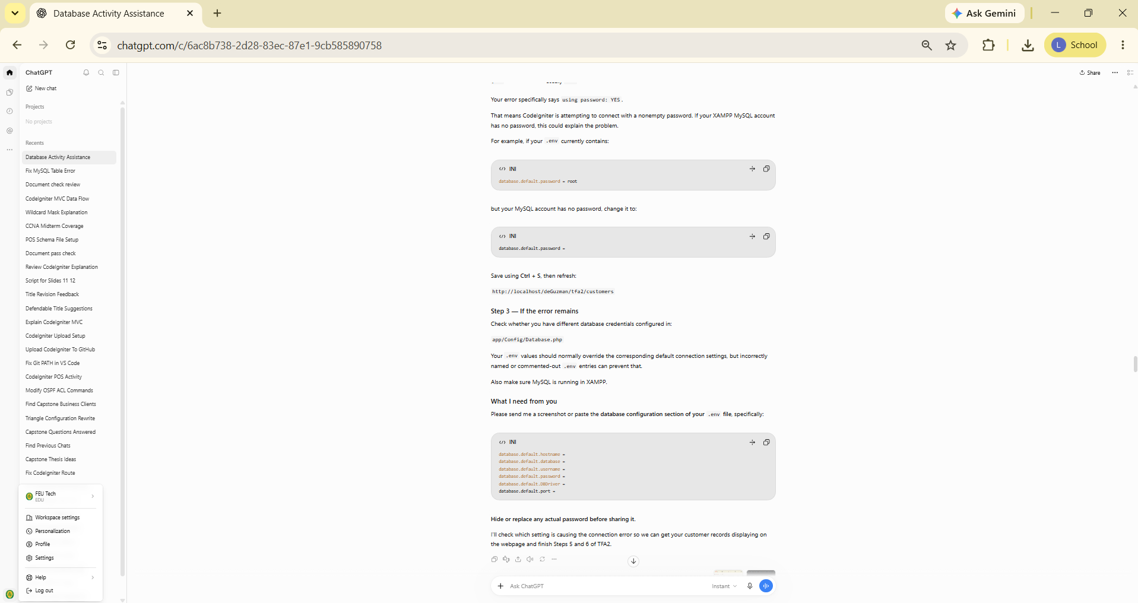
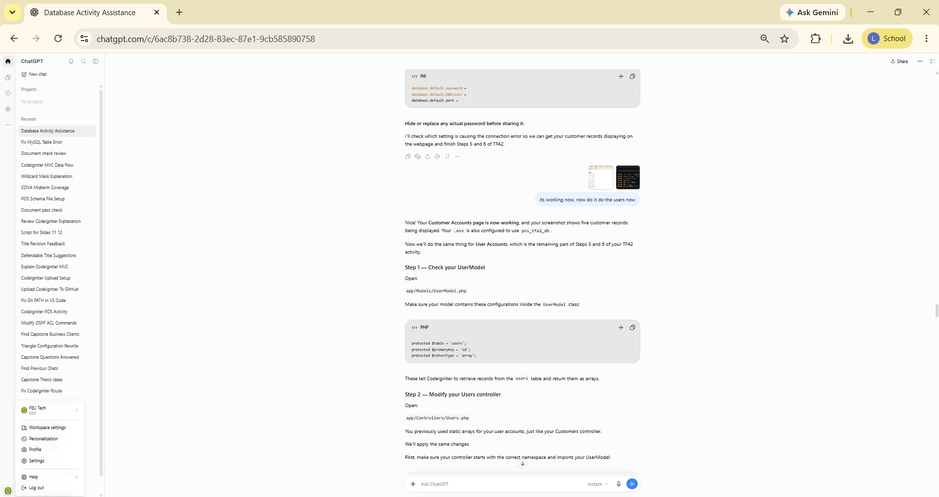
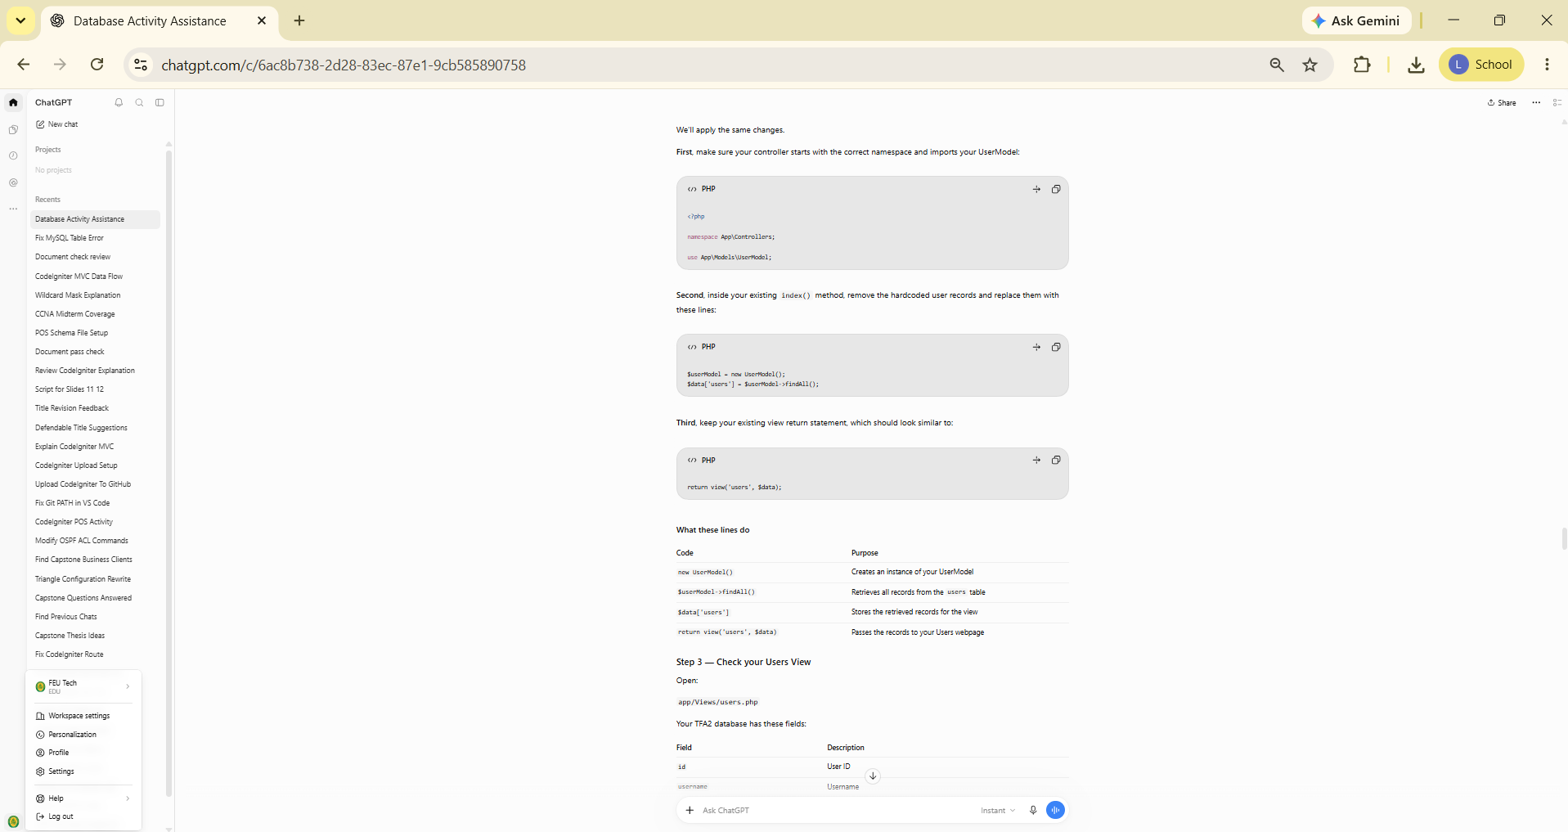
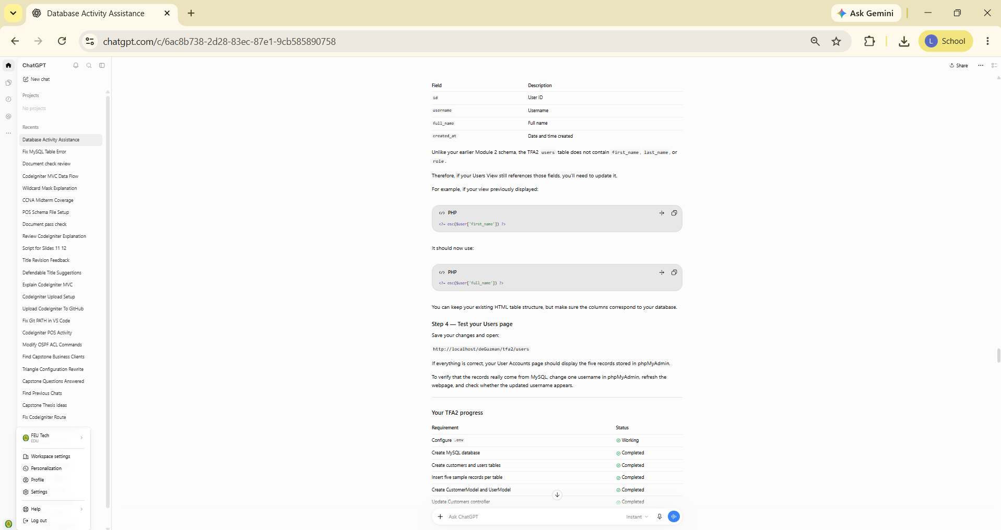
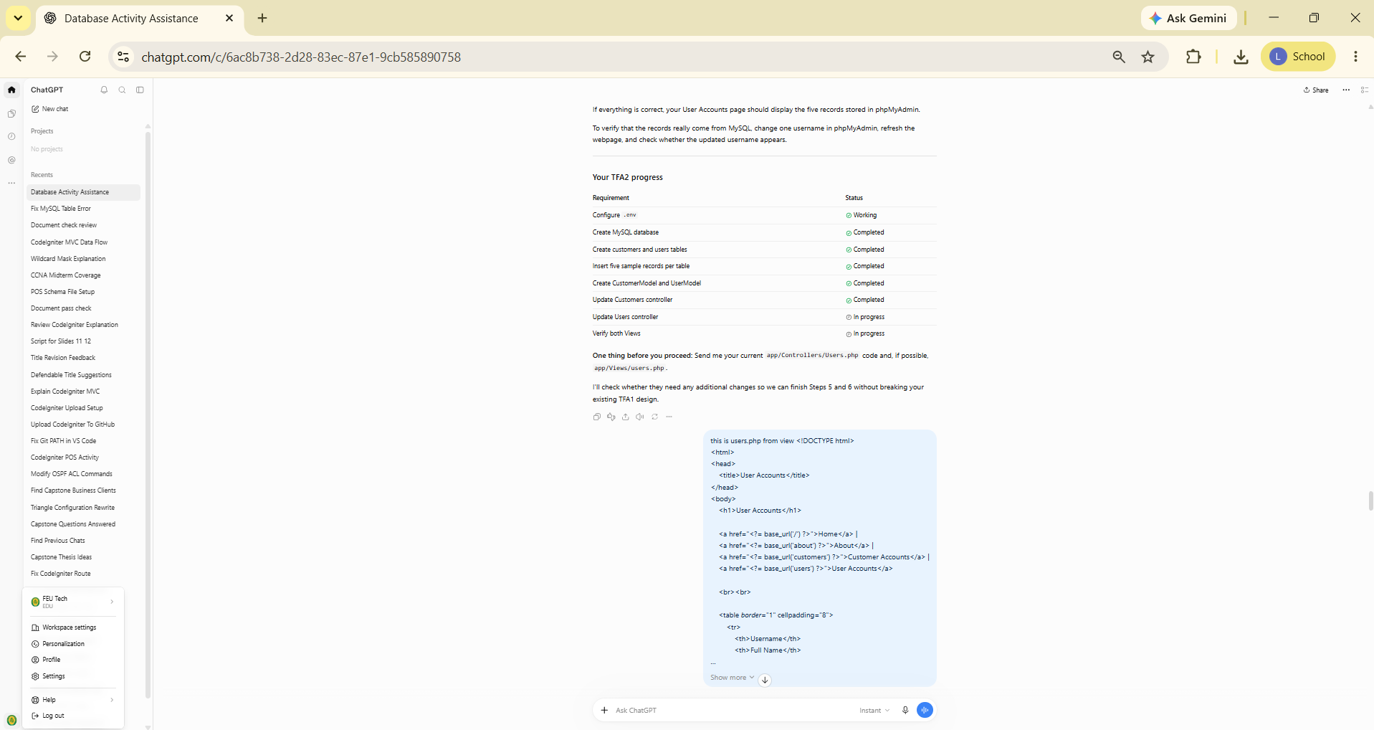
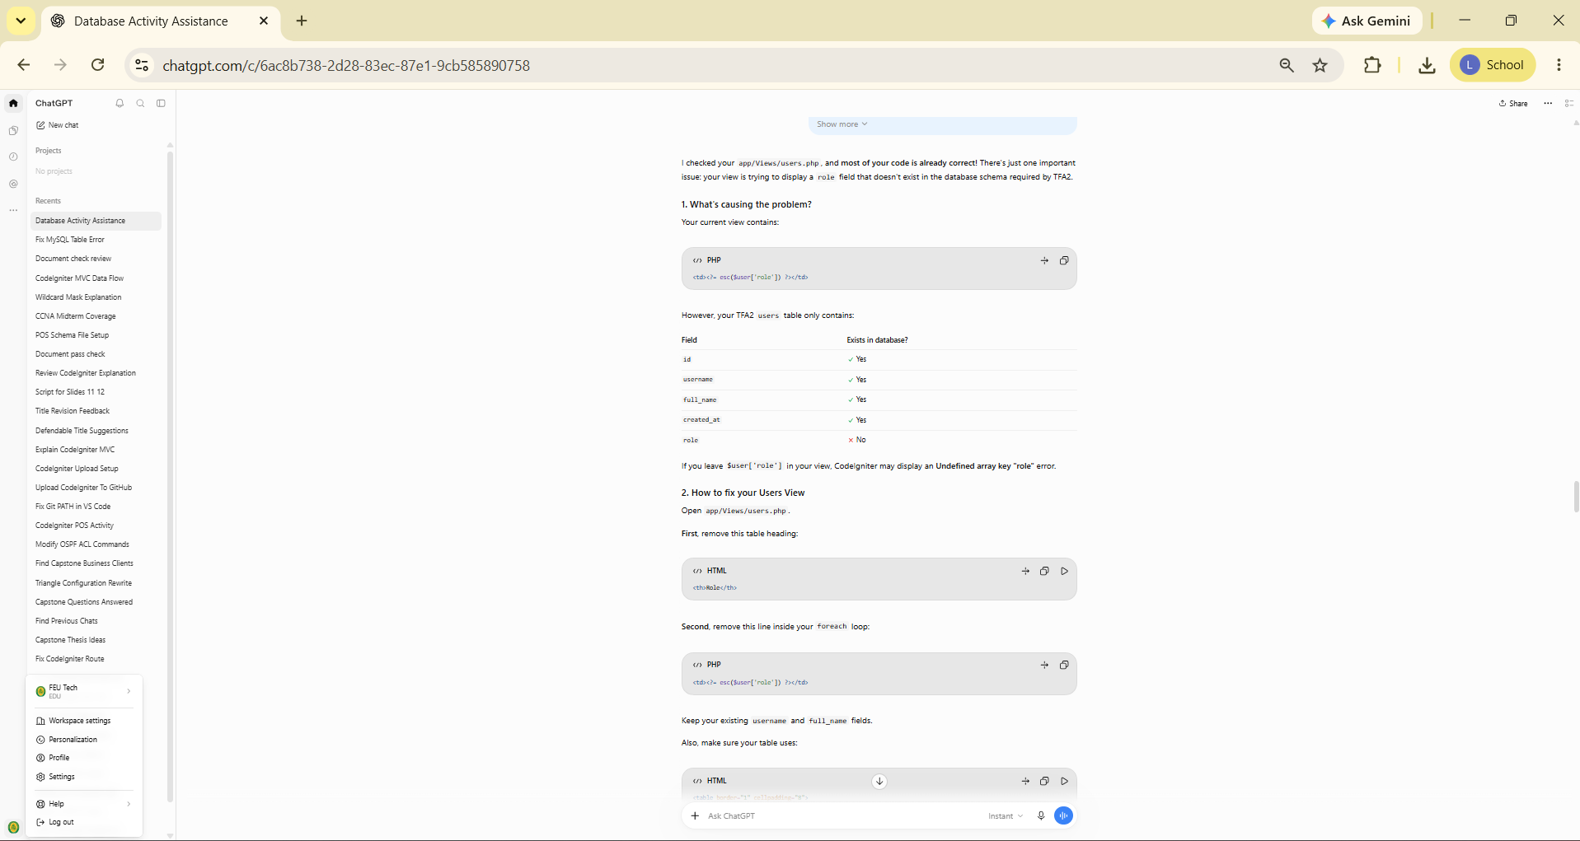
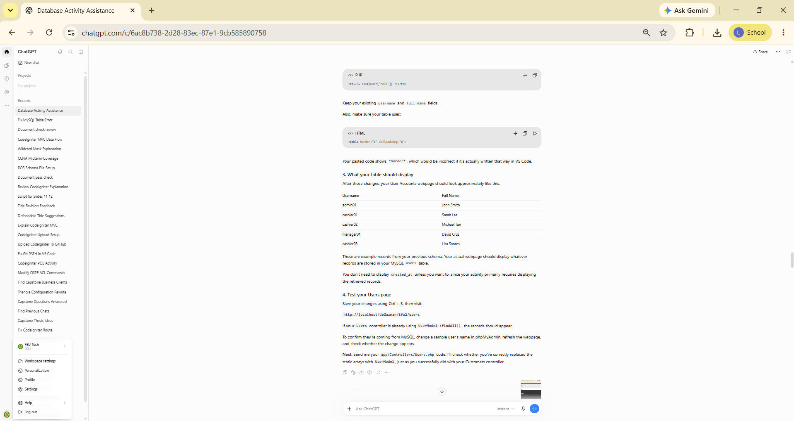
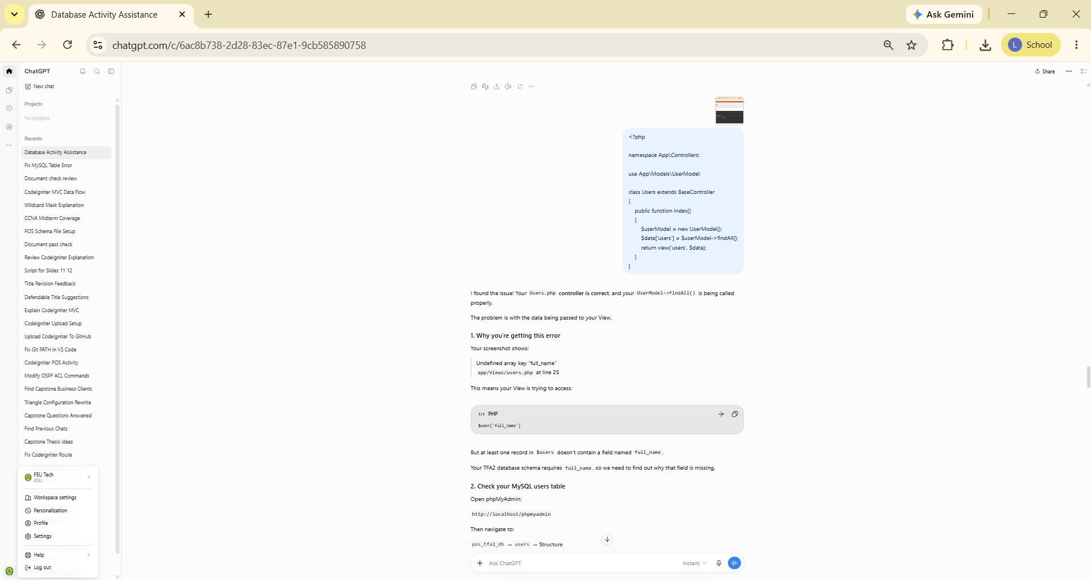
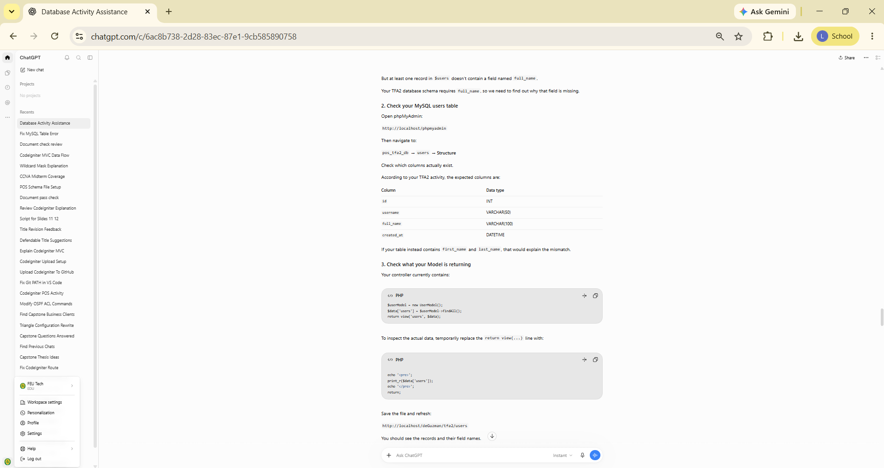
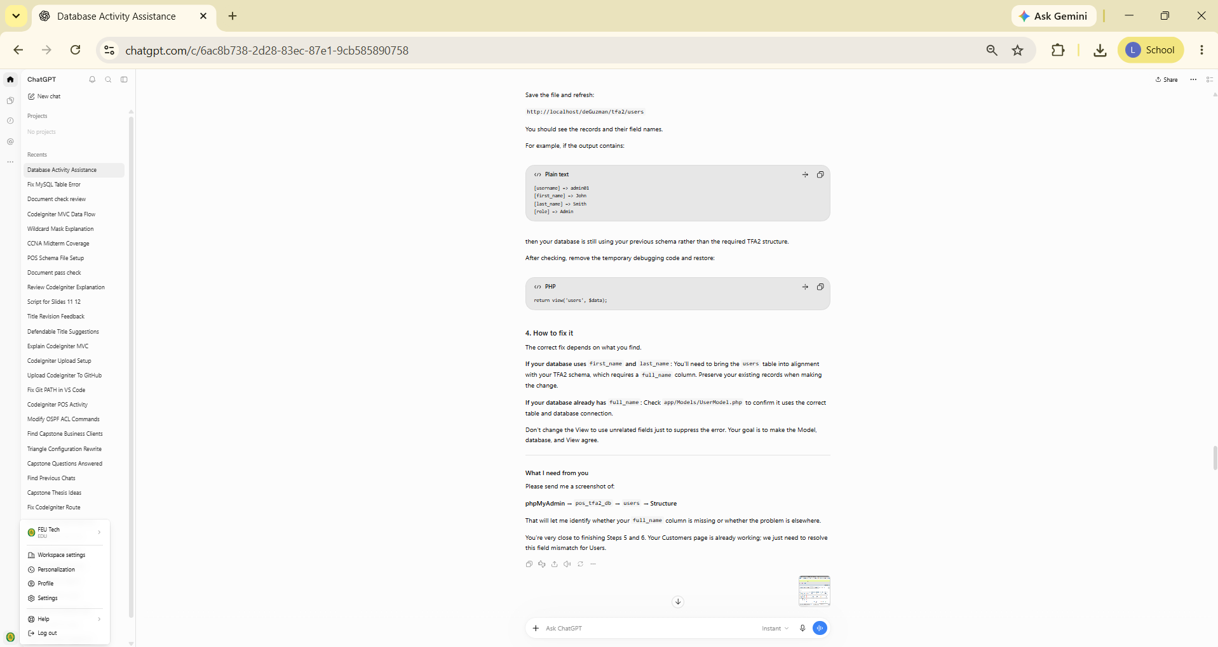
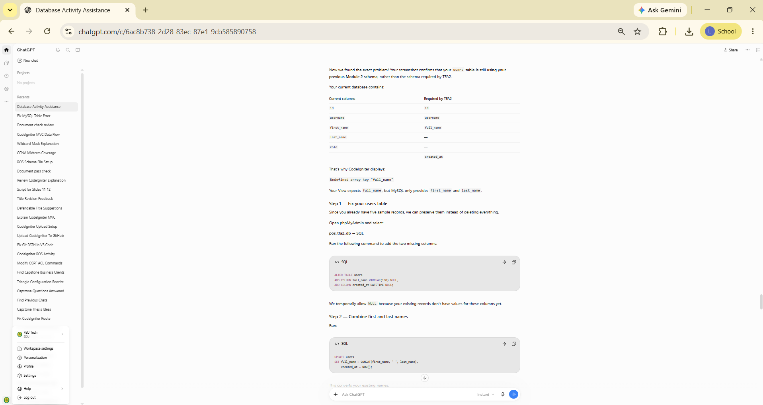
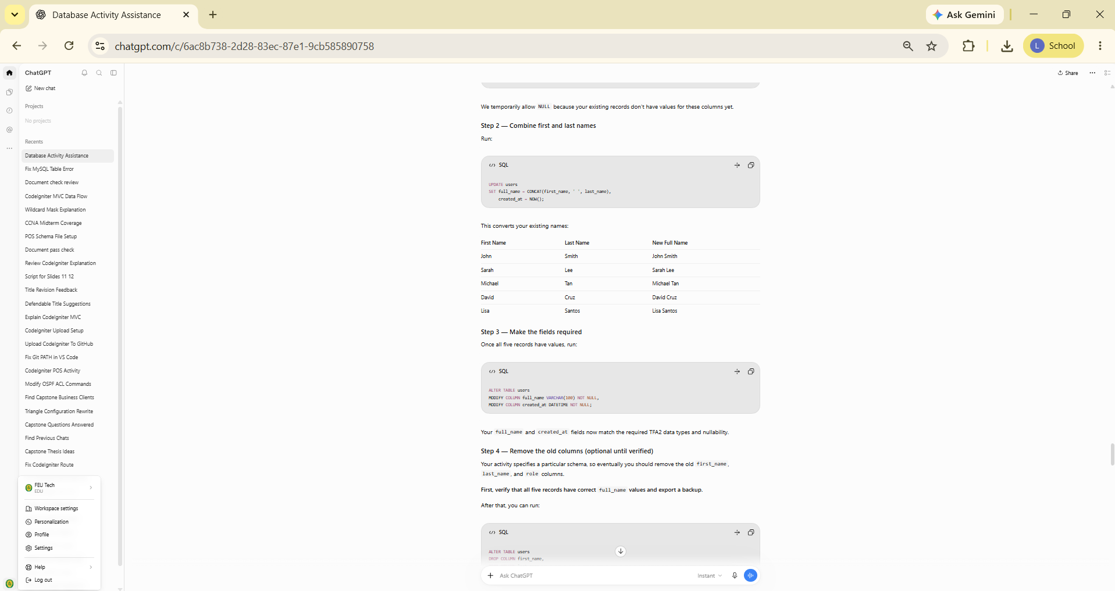

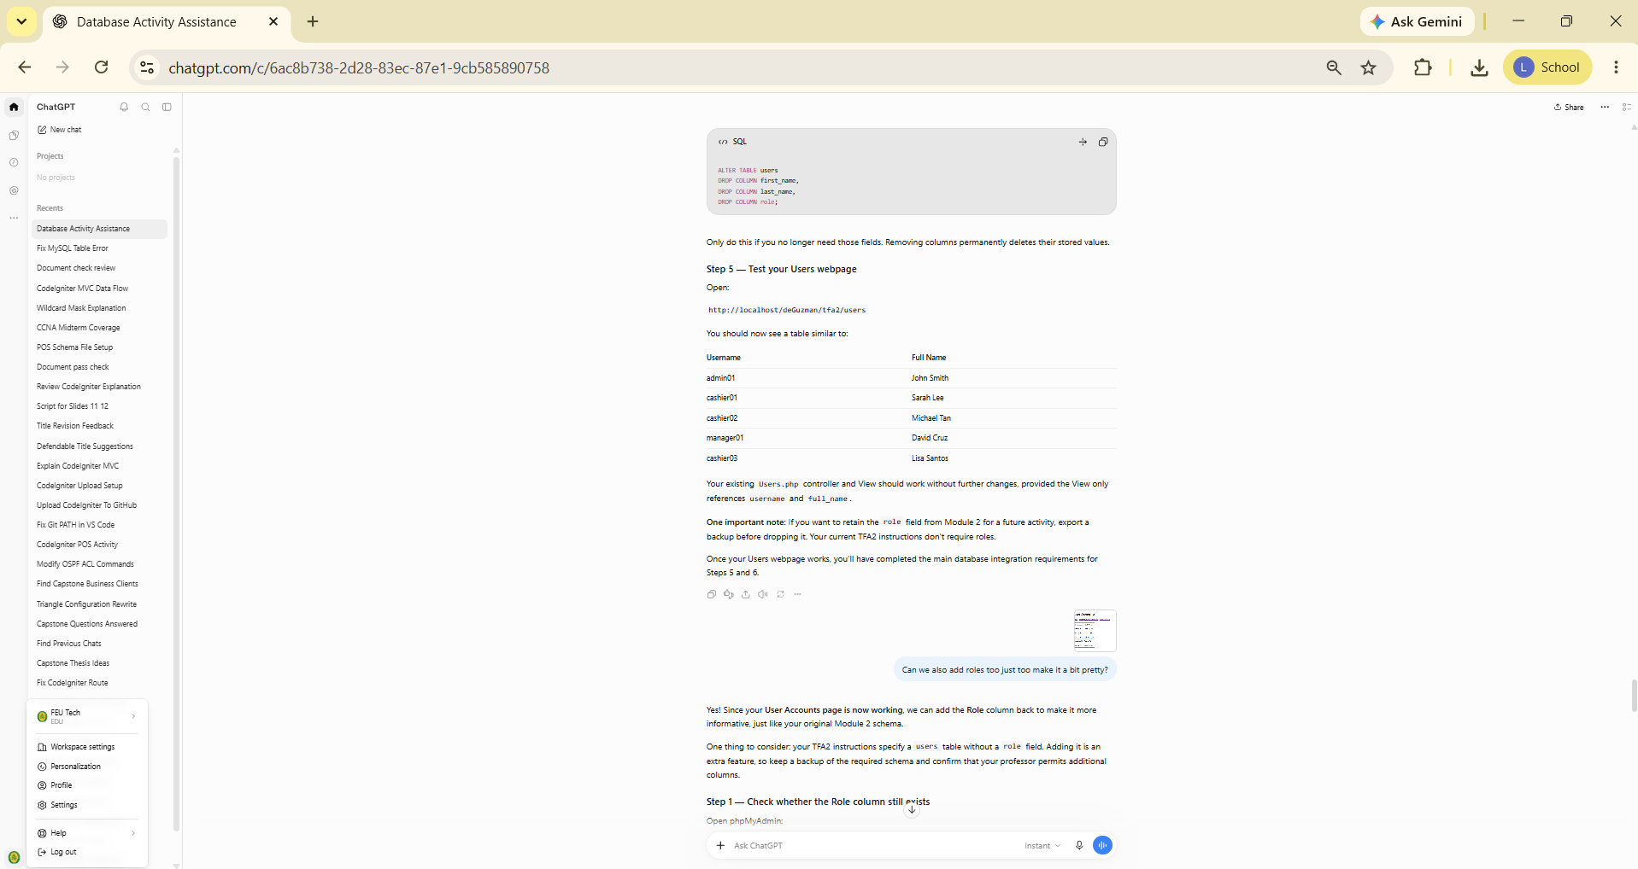
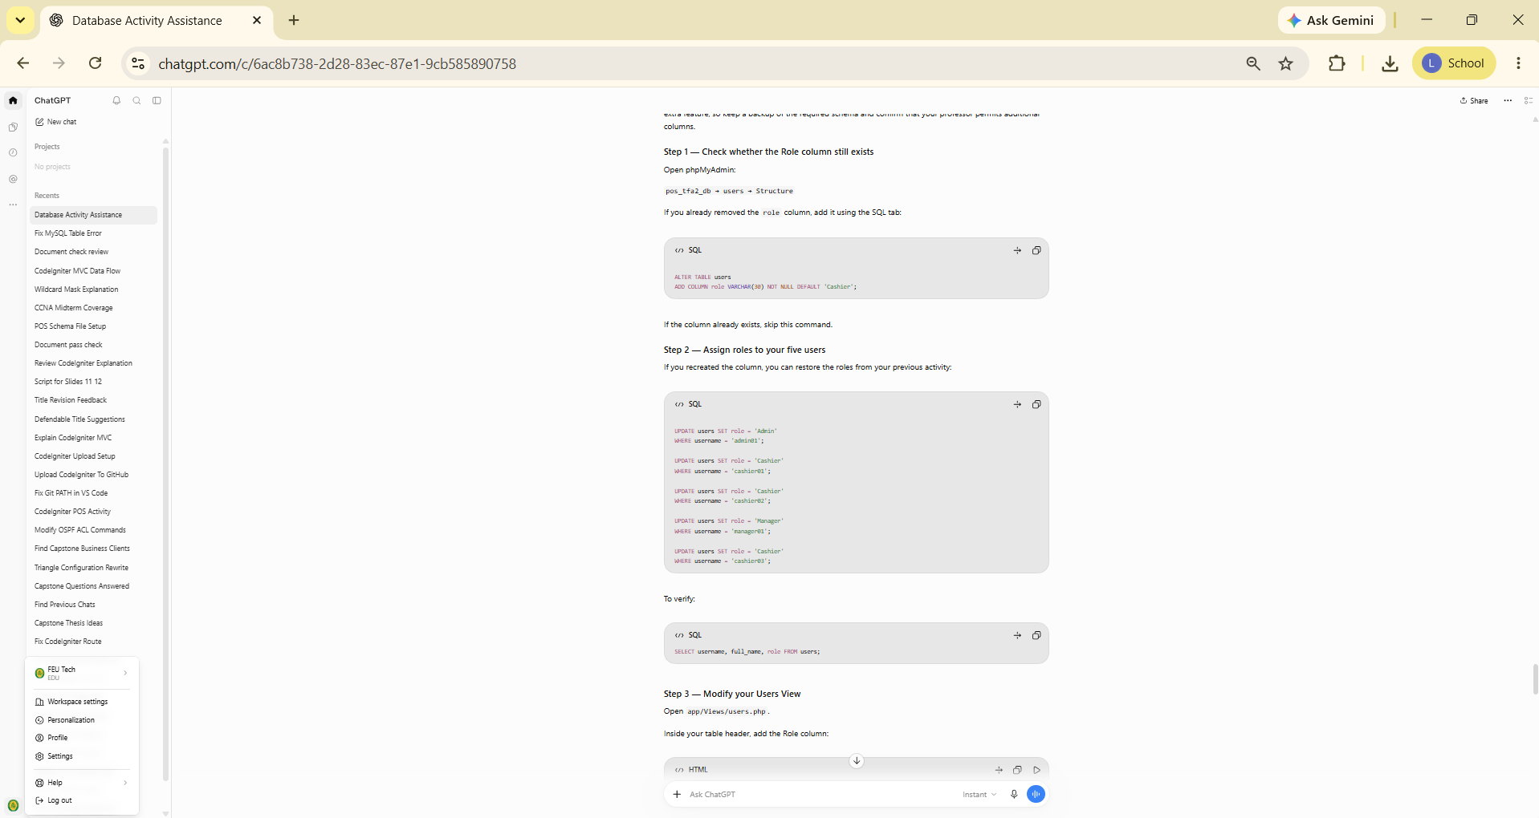
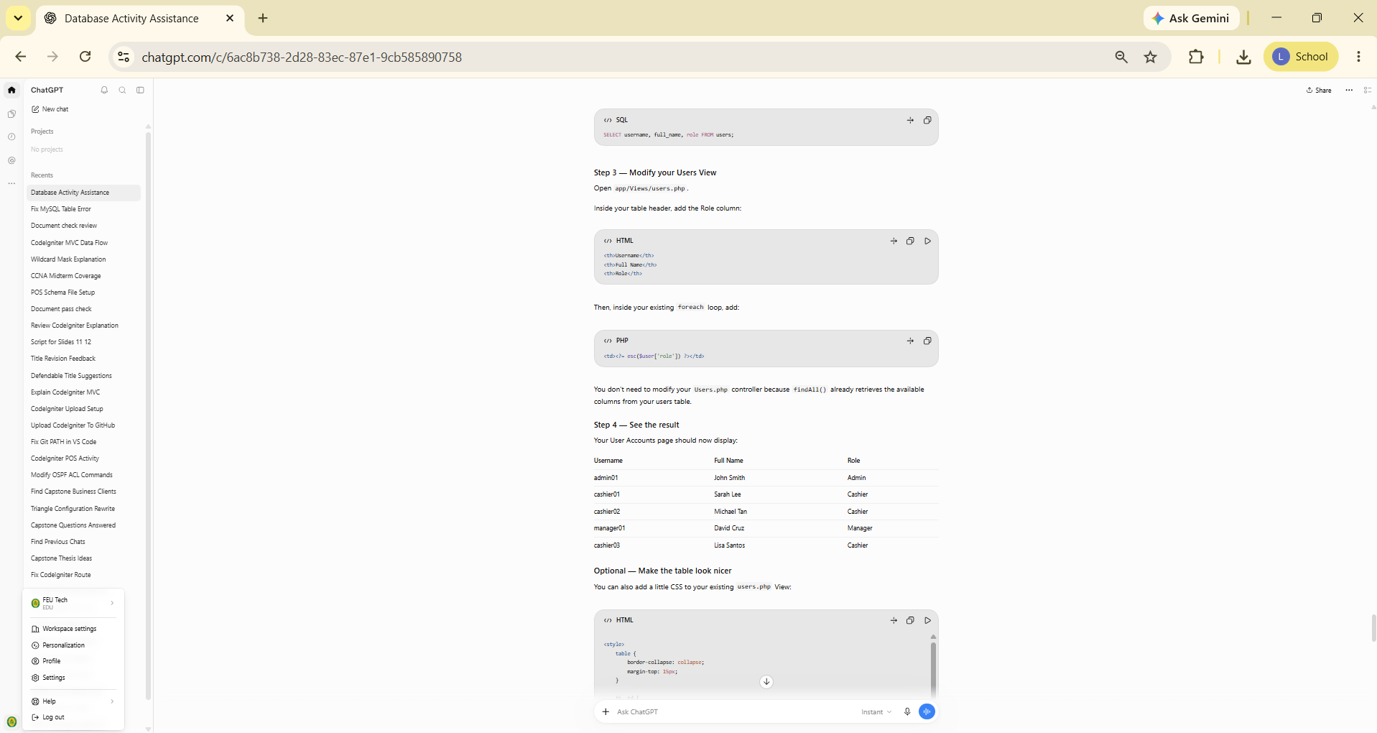
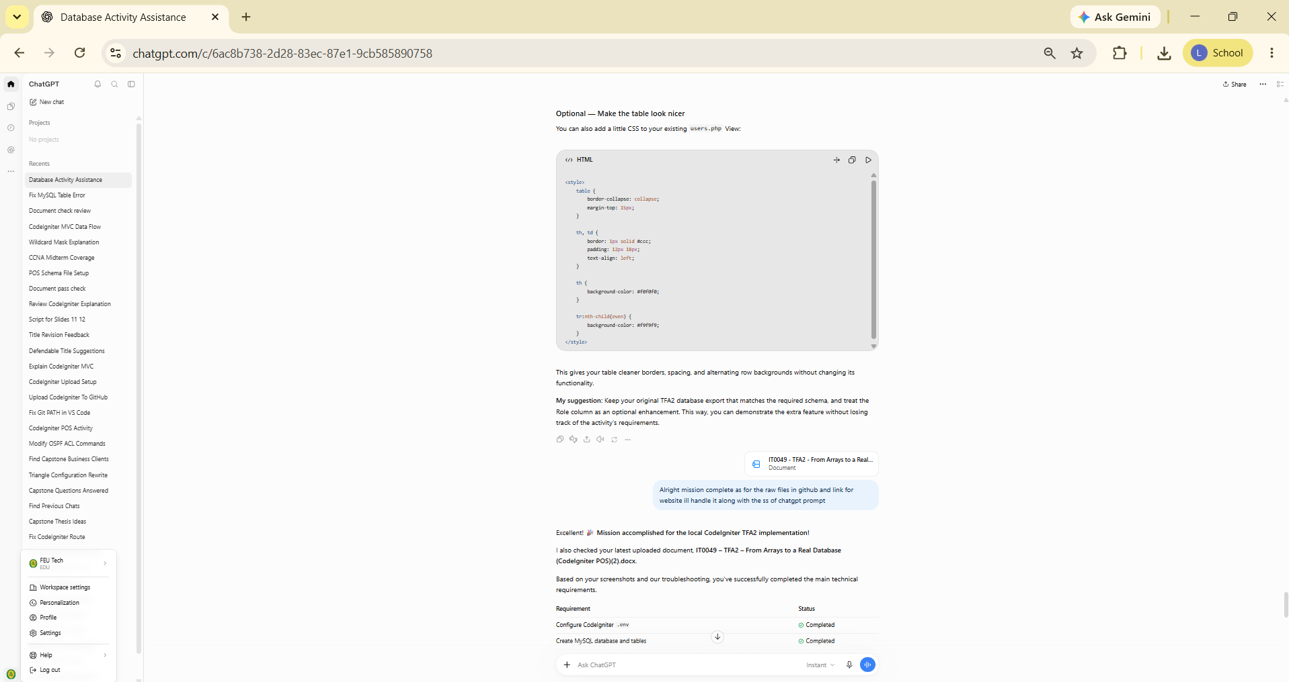
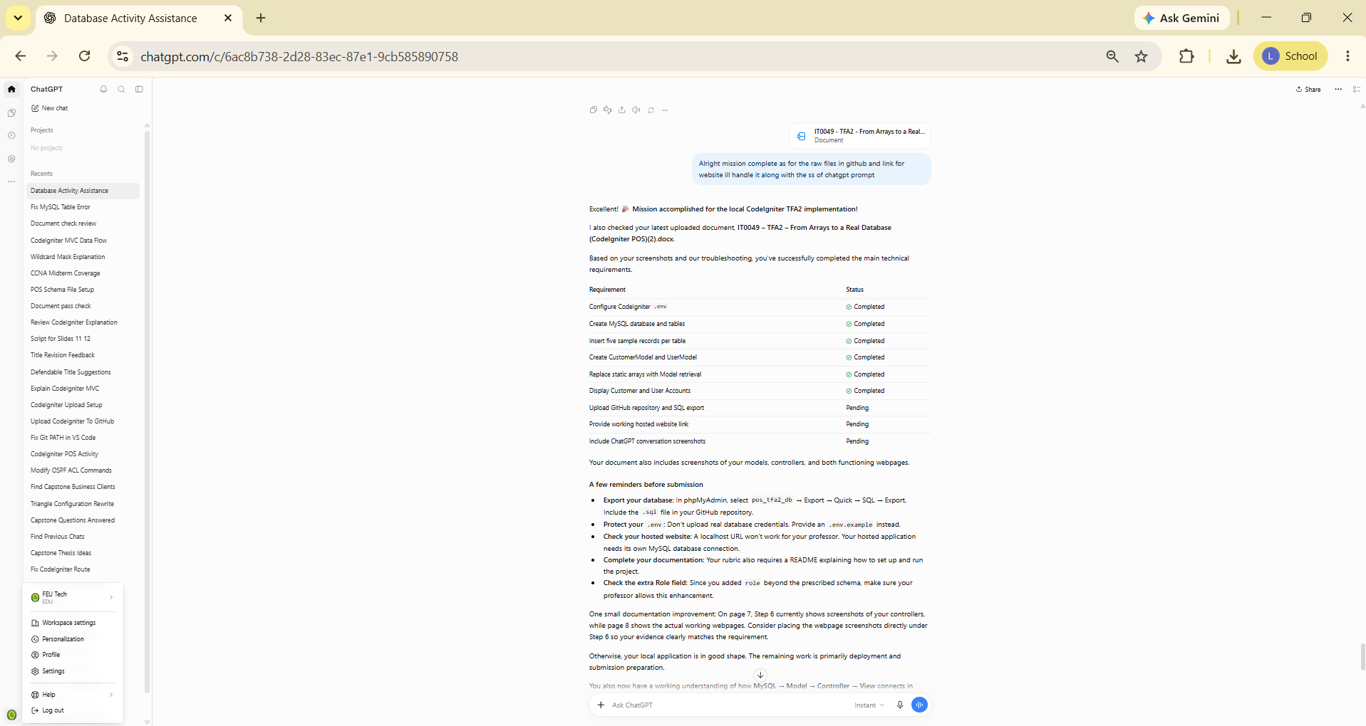
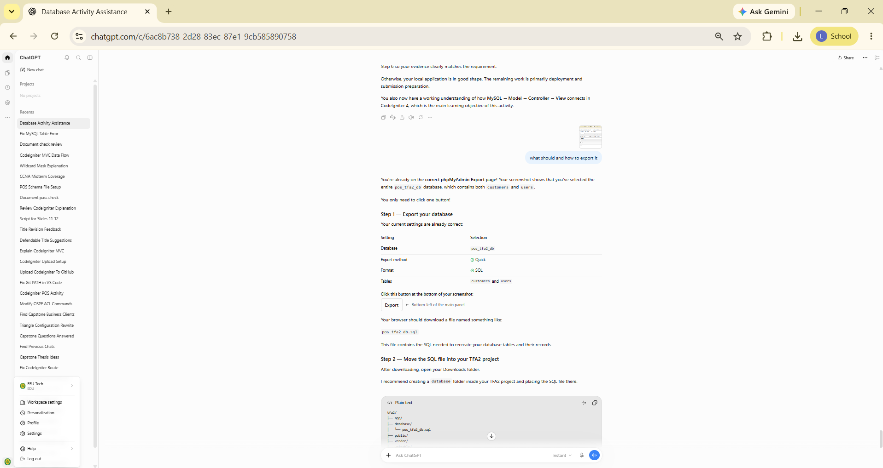
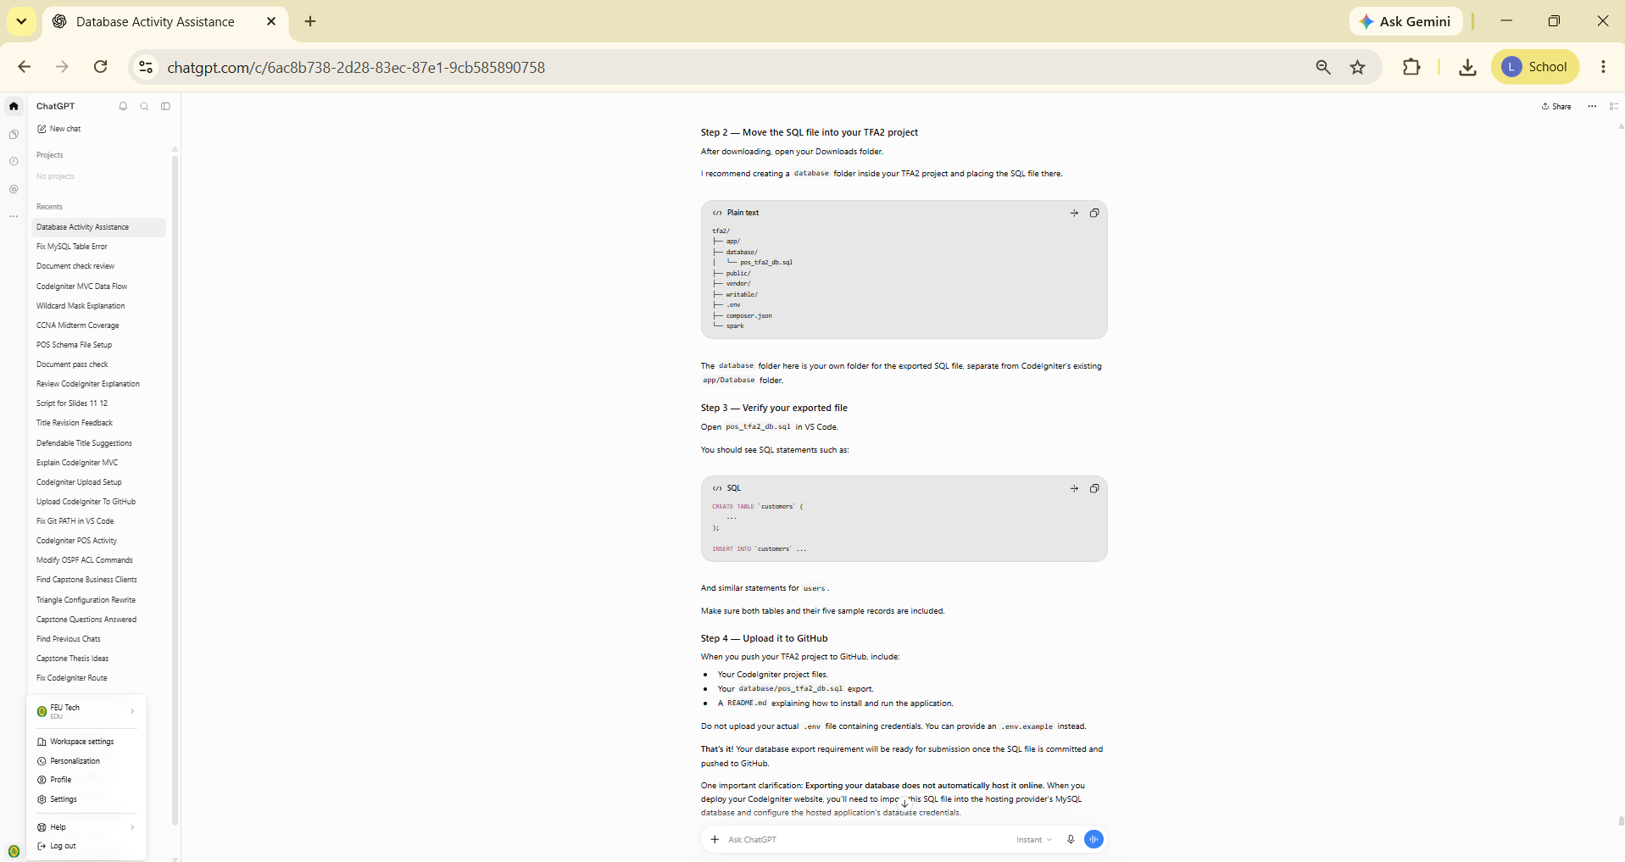
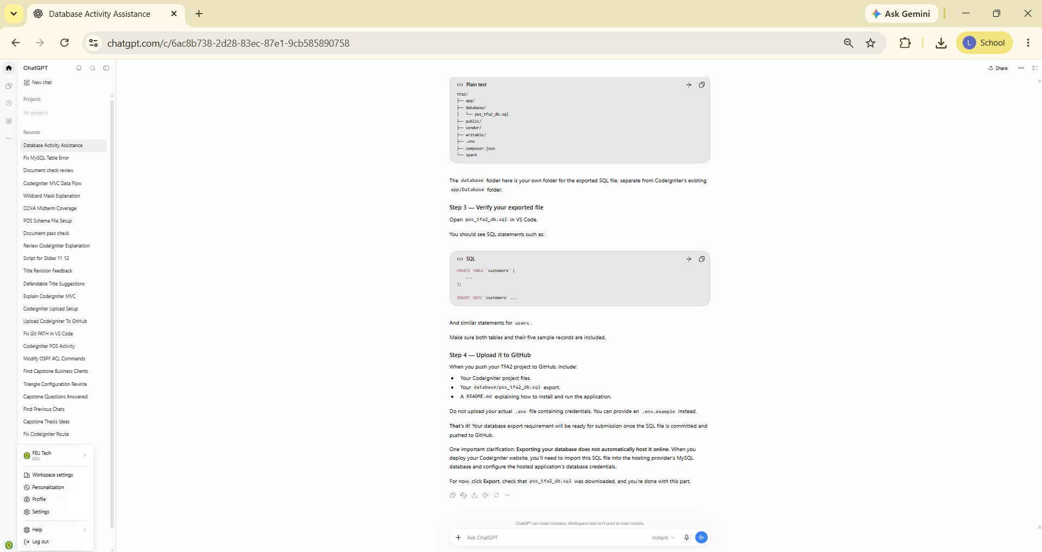
REFERENCES

- Manfield, A. (2021). Pro CodeIgniter: Learn how to create professional web-applications with PHP.
- CodeIgniter User Guide. Models. https://codeigniter4.github.io/userguide/models/model.html
- CodeIgniter User Guide. Query Builder. https://codeigniter4.github.io/userguide/database/query_builder.html

